 | 
COUNCIL ASSESSMENT REPORT
WESTERN REGIONAL PLANNING PANEL

PANEL REFERENCE & DA NUMBER | PPSWES-218 – DA016/24
PROPOSAL | Educational Establishment (Private School)
ADDRESS | Magpie Hollow Road, South Bowenfels NSW 2790 being Lot 1 DP 527491 and Lot 21 DP 816671 for the new stormwater easement
APPLICANT | Tim Pridham on behalf of The Trustee for Katoomba Education Trust
OWNER | - Met-Mt Victoria Campus Pty Ltd (Lot 1 in DP527491)  - Mr Wayne and Mrs Gwyneth Clark- Stormwater Easement (Lot 21 DP 816671)
DA LODGEMENT DATE | 18 March 2024
APPLICATION TYPE | Integrated Development Application
REGIONALLY SIGNIFICANT CRITERIA | The proposed development is for an educational establishment with an estimated development cost of more than $5m; therefore, it is regionally significantly development pursuant to clause 5(b) of Schedule 6 of State Environmental Planning Policy (Planning Systems) 2021.
CIV | $10,817,262.00 (excluding GST)
CLAUSE 4.6 REQUESTS | N/A.
KEY SEPP/LEP | Environmental planning instruments  In determining the development application, the following environmental planning instruments will be considered pursuant to s 4.15(1)(a)(i) of the Environmental Planning & Assessment Act 1979:  - State Environmental Planning Policy (Planning Systems) 2021,  - State Environmental Planning Policy (Biodiversity & Conservation) 2021,  - State Environmental Planning Policy (Resilience & Hazards) 2021,  - State Environmental Planning Policy (Transport and Infrastructure) 2021,  - Lithgow Local Environmental Plan 2014 (LLEP2014)  Development control plan  In determining the development application, the following development control plan will be considered pursuant to s 4.15(1)(a)(iii) of the Environmental Planning & Assessment Act 1979:  - Lithgow City Development Control Plan 2021  Contributions plan  The Lithgow City Council Local Infrastructure Contributions Plan (Section 7.12) 2024 applies to the development proposal.
TOTAL & UNIQUE SUBMISSIONS KEY ISSUES IN SUBMISSIONS | The development was publicly notified in accordance with the Lithgow Community Participation Plan 2020 (CPP) and the provisions of Environmental Planning and Assessment Regulations 2021 (EP&A Regulation). The notification period was for a minimum of 28 days from 21 March 2024 to 18 April 2024.  Three (3) submissions were received during the notification period by way of objection.  The key issues involve:  - Lack of Infrastructure ie. walking and cycling facilities, bicycle parking, signage,  - Sustainable Design Elements, e.g. cross-flow ventilation, light colour roof, tree canopy across the carpark.  - Tree Canopy and Mental Wellbeing i.e. open space areas and vegetation,  - Fencing and Screening around boundaries,  - Stormwater and Easements,  - Traffic Impacts.
DOCUMENTS SUBMITTED FOR CONSIDERATION | - Architectural Plans; Brett Moulds Design & Drafting, dated 30/10/2024, Rev ZA,  - External Renders; OneSchool Global, N.D,  - General Arrangement Plan, Calare Civil, dated 19/06/2024, Rev B,  - Carpark Certification, Motion Traffic Engineers Pty Ltd, dated Jine 2024, Rev 1c,  - Traffic and Impact Assessment, Motion Traffic Engineers Pty Ltd, dated October 2024, Rev 1c,  - Road Signage Plan, Brett Moulds Design & Drafting, dated 29/02/2024, Rev U,  - Vehicle Swept Paths, Brett Moulds Design & Drafting, dated 03/10/2024, Rev X,  - Landscape Plans, Paul Scrivener Landscape, dated 13/09/2024, Rev B,  - Retaining Wall Construction Details, Calare Civil, dated 16/09/2024, Rev A,  - Bush Fire Assessment Report, Bushfire Planning & Design, dated 02/02/2024,  - Construction Management Plan, Tim Pridham, dated 20/02/2024,  - External Colour Schedule, Ashan, dated 25/09/2024,  - Geotechnical Investigation Report, Australian Ground Sciences Pty Ltd, dated 13 September 2024,  - Noise Assessment, Muller Acoustic Consulting, dated February 2024,  - Operations Manual, OneSchool Global, October 2024,  - Preliminary Site Investigation with Targeted Sampling, Australian Ground Sciences Pty Ltd, dated 4 November 2024,  - Security Fencing Brochure, Fencing & Gate Centre, N.D  - NABERS Embodied Emissions Report, Certified Energy, dated 22/03/2024,  - Flood Impact Statement, Calare Civil, 8 July 2024,  - Water Cycle Management Study, Calare Civil, 18/09/2025.
SPECIAL INFRASTRUCTURE CONTRIBUTIONS (S7.24) | The site is not located in an area that Special Infrastructure Contributions (SIC) apply.
RECOMMENDATION | Approval subject to conditions of consent.
DRAFT CONDITIONS TO APPLICANT | Yes, 20 October 2025.
SCHEDULED MEETING DATE | 11 November 2025.
PREPARED BY | Lauren Stevens-Development Planner; Lithgow Council.
DATE OF REPORT | 11 November 2025.

EXECUTIVE SUMMARY
Tim Pridham on behalf of The Trustee for Katoomba Education Trust (the Applicant) has lodged an application being DA016/24 for the development of an educational establishment on land known as Lot 1 DP 527491, Magpie Hollow Road, South Bowenfels.

The school is proposed to accommodate approximately one-hundred and fourteen (114) students from Kindergarten to Year 12, and twenty (20) teachers and ancillary staff/employees.

The hours of operation includes:
• Core student hours – 8:30am to 3:30pm,
• Hours (teachers) – 8am to 5pm,
• Some extracurricular activities on site (i.e. sport training, performance rehearsals etc) –possible twice a term practice or set up activity day out of hours.
• Infrequent fete/ community type days on a couple of Saturdays a year.
• Infrequent mowing and yard maintenance by volunteers and Contractors on weekends.
• Infrequent P&F Meetings in evenings during the year.

The development involves a two (2) storey building, carparking, outdoor sports field and associated landscaping/stormwater infrastructure.

The carparking area is proposed to consist of 55 spaces, (including an accessible space, staff parking, and minivan parking). There are separate entry and exit points from Magpie Hollow Road, a drop off/pick up zone, pedestrian walkway, 2-way vehicle manoeuvring area and landscaping throughout.

The carparking area is proposed to be located in front of the building with security gates along the front and around the boundaries of the property.

The school building is proposed to contain a setback of 33m from the front southern boundary, behind the proposed carparking area, 20m from the adjoining western boundary, 18m from the rear northern boundary and 41.8m from the adjoining eastern boundary.

The building is split into two sections via a foyer down the middle that contains a lift and staircase.

The subject land is zoned R2 Low Density Residential under Lithgow Local Environmental Plan 2014 (LLEP2014). Educational establishments are prohibited in the R2 zone under the LLEP2014.

However, State Environmental Planning Policy (Transport and Infrastructure) 2021 (T&I SEPP) prevails to the extent of any inconsistency with another environmental planning instrument (cl 3.6(1)).

Clause 3.36(1) of Part 3.4 of Chapter 6 of the T&I SEPP provides that development for the purpose of a school may be carried out by any person with development consent on land in a prescribed zone.

Clause 3.34(f) of the T&I SEPP declares Zone R2 Low Density Residential as a prescribed zone.

Therefore, development of a school is permissible with consent on the land.

The principle planning controls relevant to the proposal include the State Environmental Planning Policy (Transport and Infrastructure) 2021, the Lithgow Local Environmental Plan 2014 and the Lithgow Development Control Plan 2021.

The development is ‘integrated development’ pursuant to section 4.46 of the Environmental Planning and Assessment Act 1979 (EP&A Act) given that an approval under section 100B of the Rural Fires Act 1997 is required. The development was also referred for concurrence to the following agencies:

- WaterNSW under section 4.13 of the EP&A Act;
- Transport for NSW under Section 2.122 and Section 3.58 of State Environmental Planning Policy (Transport and Infrastructure) 2021; and
- Endeavour Energy under Section 2.48 of State Environmental Planning Policy (Transport and Infrastructure) 2021.
The development is identified as ‘regionally significant development” pursuant to clause 5(b) of Schedule 6 of the State Environmental Planning Policy (Planning Systems) 2021 because it consists of development of an educational establishment with an estimated development const of more than $5m.

As such, The Central West Regional Planning Panel (the Panel) is the consent authority for the application.

The planning instruments, approvals and guidelines that are relevant to the proposal include:

- State Environmental Planning Policy (Biodiversity & Conservation) 2021,
- State Environmental Planning Policy (Planning Systems) 2021,
- State Environmental Planning Policy (Resilience & Hazards) 2021,
- State Environmental Planning Policy (Transport and Infrastructure) 2021,
- Lithgow Local Environmental Plan 2014 (LLEP2014) and
- Lithgow Development Control Plan 2021.

Several pre-conditions/jurisdictional prerequisites are required to be satisfied before the granting of consent. These are listed in the following table and are considered to have been satisfactorily addressed by the documentation submitted.

State Environmental  Planning Policy  (Biodiversity &  Conservation) 2021 | Chapter 2 Vegetation in non-rural areas  - Clause 2.6 - Clearing that requires a permit or approval states:  - a person must not clear vegetation in any non-rural area of the State without the authority confirmed by a permit granted by the council.  Chapter 6: Water Catchments  - Clause 6.64 - provides that the concurrence of the Regulatory Authority is required.
State Environmental Planning Policy (Planning Systems) 2021 | Schedule 6: Regionally Significant Development  - Clause 5: Private infrastructure and community facilities over $5 million.
State Environmental  Planning Policy  (Resilience & Hazards)  2021 | Chapter 4: Remediation of Land  - Clause 4.6 - Contamination and remediation to be considered in determining development applications
State Environmental Planning Policy (Transport and Infrastructure) 2021 | Chapter 2: Infrastructure  - Subdivision 2 Development likely to affect an electricity transmission or distribution network  - Section 2.48(2) (Determination of development applications—other development) – electricity transmission - the proposal satisfies this section, subject to recommended conditions.  - Subdivision 2 Development in or adjacent to road corridors and road reservations  - Section 2.122 Traffic-generating development  Chapter 3: Educational Establishments and Child Care Facilities  - Part 3.4 Schools-Specific Development Controls  - Section 3.36 School-development permitted with Consent  - Part 3.7 General Development Controls  - Section 3.58 Traffic Generating Development  Schedule 8 Design Quality Principles in Schools-Chapter 3
Lithgow Local  Environmental Plan  2012 (LLEP2014) | - Clause 2.3 – Zone Objectives and Land Use Table  - Clause 7.1 – Consideration of earthworks  - Clause 7.3 – Stormwater management  - Clause 7.5 - Groundwater Vulnerability  - Clause 7.10 - Essential services
The Lithgow Development Control Plan 2021 (LDCP2021) | - Chapter 2 – Site Requirements  - Chapter 3 – Environment and Hazards  - Chapter 7 – Commercial, Community & Industrial Development (including Advertising/Signage)

The application was placed on public exhibition from 21 March 2024 to 18 April 2024. During the notification period three (3) submissions were received with no objections subject to recommendations.

The submissions over the notification period raised the following issues:

- Lack of Infrastructure ie. walking and cycling facilities, bicycle parking, signage,
- Sustainable Design Elements, e.g. cross-flow ventilation, light colour roof, tree canopy across the carpark,
- Tree Canopy and Mental Wellbeing i.e. open space areas and vegetation,
- Fencing and Screening around boundaries,
- Stormwater and Easements,
- Traffic Impacts.

These issues are considered further in this report.

Following a detailed assessment of the proposal, pursuant to Section 4.16(1)(b) of the EP&A Act, DA016/24 is recommended for approval subject to conditions contained at Attachment A of this report.

- THE SITE AND LOCALITY

  - The Site

The subject property is Lot 1 DP 527491, Magpie Hollow Road, South Bowenfels.

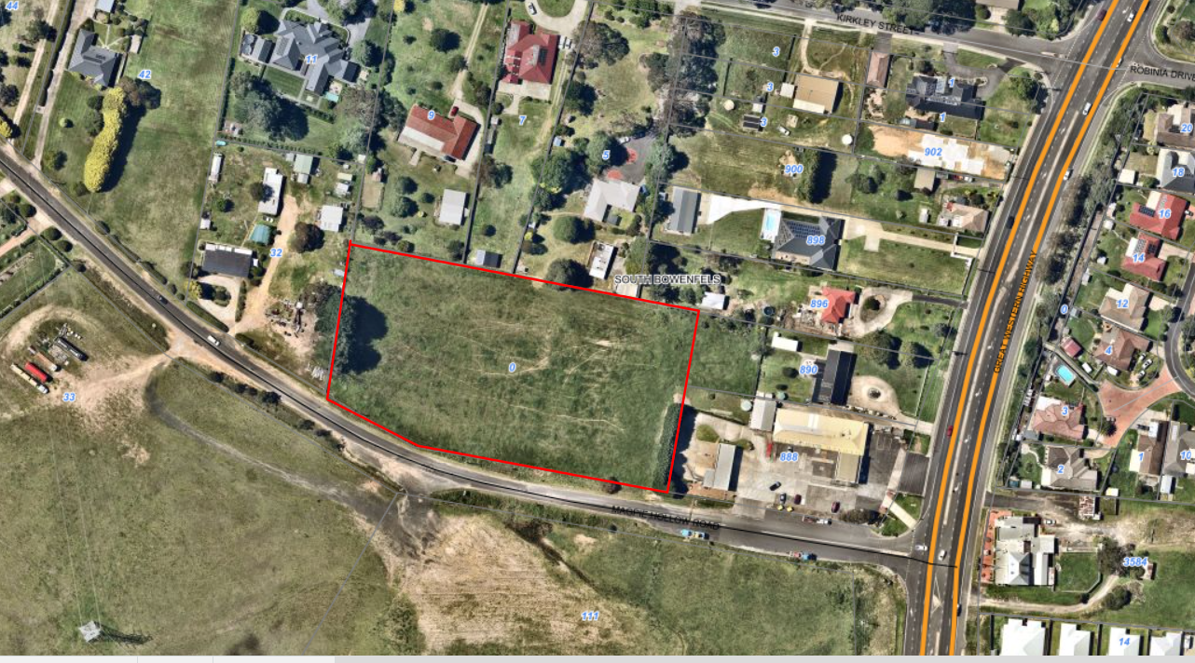
Figure 1: Aerial Image of the development site,2024

The subject site comprises a total area of 1.17ha, with a 154m frontage along Magpie Hollow Road, and approximately 80m depth.

The property is located approximately 105m from the corner of the Great Western Highway and Magpie Hollow Road, approximately 10km to the Lithgow Town Centre, and approximately 5km to a popular tourist destination known as Lake Lyell.

The development site contains a relatively flat topography with some large vegetation located on the eastern boundary which adjoins a service station with café and car wash. Residential dwellings are located to the west and north of the site, and opposite the site to the south is vacant land which is approved for a 79 lot subdivision.

The four dwellings to the north, one dwelling to the west, and the residential subdivision to the south have a slightly lower elevation to the development site. These lots comprise areas ranging from 3000m² to 5000m².

An above ground power line and poles are located in front of the property within the road reserve.

Water services are located within the Magpie Hollow Road reserve and sewer mains connect to the property from the north east of the site.

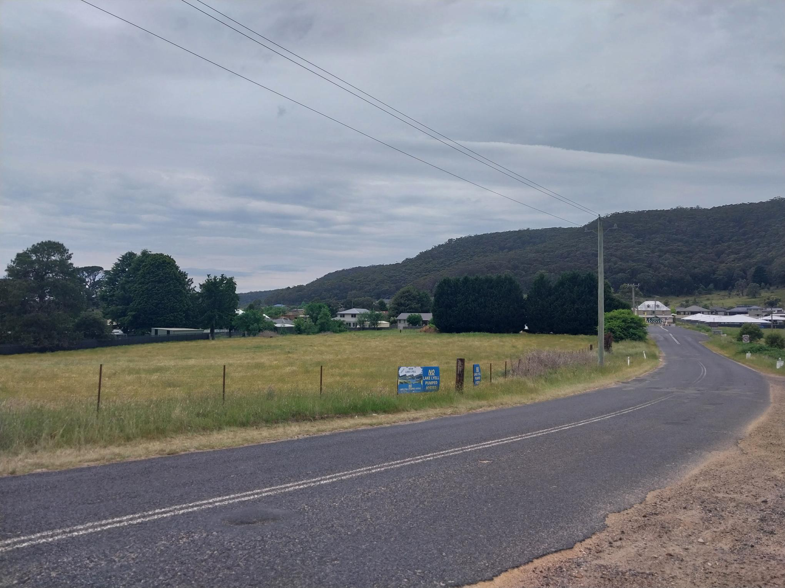
Figure 2: Photo of the property from Magpie Hollow Road, north, north east direction, 7 November 2024

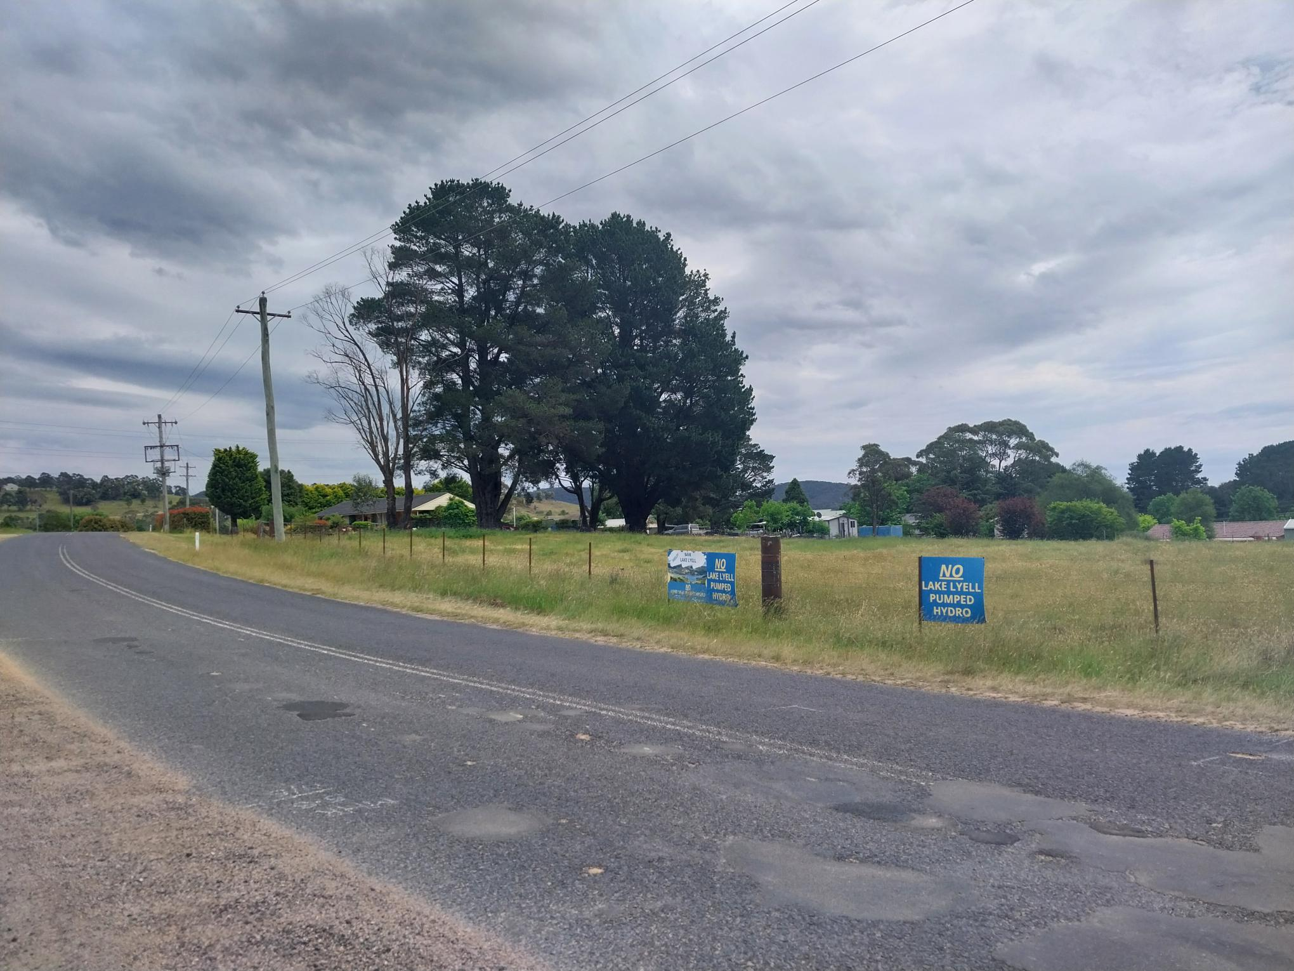
Figure 3: Photo of the property from Magpie Hollow Road, north west direction, 7 November 2024

  - The Locality

The site’s local context is defined by Magpie Hollow Road to the South, residential development to the north and west and a service station and car wash adjoins the site to the east (corner of the Great Western Highway and Magpie Hollow Road).

The land adjacent to the property on Magpie Hollow Road is currently vacant of building structures, with a past approval granted for a 79 Lot Residential Subdivision as per DA022/18 (yet to be developed). The proposed public access road for the subdivision is proposed to be located adjacent to the proposed exit driveway to the development.

- THE PROPOSAL AND BACKGROUND

  - The Proposal

The application is seeking consent for the development of an educational establishment (school), carparking, outdoor sports area and associated landscaping/stormwater infrastructure.

The carparking area is proposed to consist of 55 spaces, (including an accessible space, staff parking, and minivan parking). There will be separate entry and exit points from Magpie Hollow Road, a drop off/pick up zone, pedestrian walkway, 2-way vehicle manoeuvring area and landscaping throughout.

The carparking area is proposed to be located in front of the building with security gates along the front and around the boundaries of the property.

The school building is proposed to contain a setback of 33m from the front southern boundary, behind the proposed carparking area, 20m from the adjoining western boundary 18m from the rear northern boundary and 41.8m from the adjoining eastern boundary.

The building is split into two sections via a foyer down the middle that contains a lift and staircase.

Location | Function | Total Floor Area
Foyer | Lift and Stairs | 230.4m²
Learning Centre Ground Floor Plan | Entry/Reception, Administration/Office and Resource Hub, IT Room, Meeting Rooms, Staff Room and Unisex Staff Amenities,  Separate Female/Male Bathrooms,  Wellbeing Room,  Focus Area and Collaborative Area,  Six (x6) Studios,  Teachers Store Room/Cleaners. | 37.9m length x 18m width = 682.2m²  An additional covered outdoor area consisting of 37.9m length x 9.09m width is also proposed to be located on the northern side of the ground floor learning centre.
Learning Centre First Floor Plan | Separate Female/Male Bathrooms,  Three (3) Large Studios,  One (1) medium studio,  Collaborative Space Area,  Three (3) Quiet Rooms,  Resource Hub/Teacher Store, Science Room and  Prep/General Store and lockers. | 37.9m length x 18m width = 682.2m²
Gymnasium Ground Floor Plan | Gymnasium with stage and store rooms,  Dining,  Canteen,  Senior Dining/Outdoor Learning,  Store Room,  Separate Female/Male Bathrooms | 44.137m length x 27.09m width = 1,195.67m²
Gymnasium First Floor Plan | Food Tech Room including store room and pantry,  Community Support Room,  Art/Design Room including project store room and material store room,  Maker Space Room with 2 store rooms,  Corridor and Void to below floor | 44.137m length x 27.09m width = 1,195.67m²
Total Indoor Area per Floor |  | Approximately 2,560.07m²

The height of the development is 6.4m excluding the roof that is proposed to contain a 5-6 degree pitch.

The building is proposed to be constructed of texture coated concrete and metal clad walls with a colourbond roof.

Council raised concerns with the applicant regarding the original architectural plans submitted 7 June 2024, and 12 September 2024.

The concerns raised included:

- Likely Impacts of the Development,
- Built Environment,
- Social Impacts,
- Landscape Plan,
- Vehicle Access/Traffic and Carparking,
- Stormwater,
- Geotechnical Report,
- Flood Impact Statement,
- Retaining Wall Plan and Elevations,
- Preliminary Site Investigation,
- Compliance with Council’s Development Control Plan 2021,
- Compliance with Transport for NSW requirements,
- Community Concerns.

A landscape plan was submitted on 16 September 2024, showing different types of landscaping/species to be located around the property boundaries and throughout the carparking area.

Vehicle access, traffic and carparking, stormwater plans and a flood impact statement were also submitted and assessed as part of the application.

Amended architectural plans were submitted by the applicant, dated 6 November 2024, showing a bicycle parking area, screened bin enclosure, a 1.2m concrete footpath along the front boundary of the property and internal alterations to room locations. The front façade of the building has also been amended to include timber batons, stepped out entry area, natural tone colours and brick work. The roof has also been structurally designed to contain different levels and orientations. This design is to help to provide a visual effect to the streetscape by breaking it up rather than containing a ‘rectangular’ building and a flat front façade.

A briefing meeting was held with the Western Region Planning Panel on 12 November 2024, with a recommendation for a full report at the determination meeting.

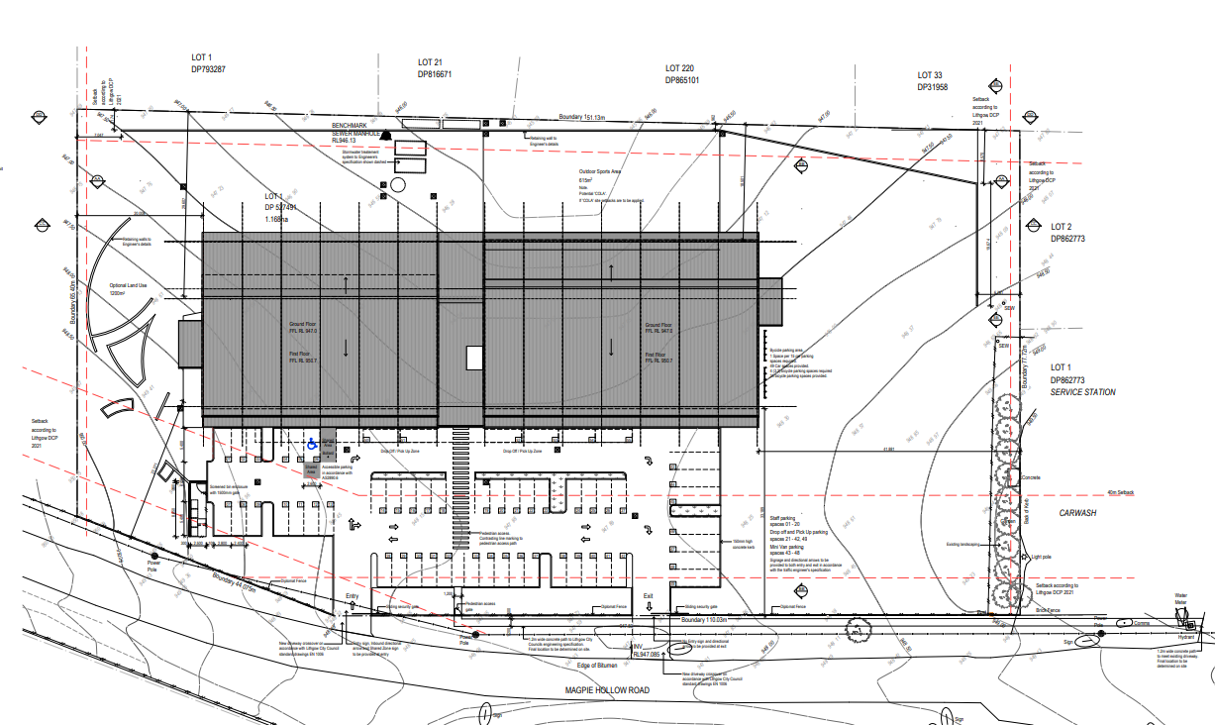
Plan 1: Site Plan of the development, 30 October 2024

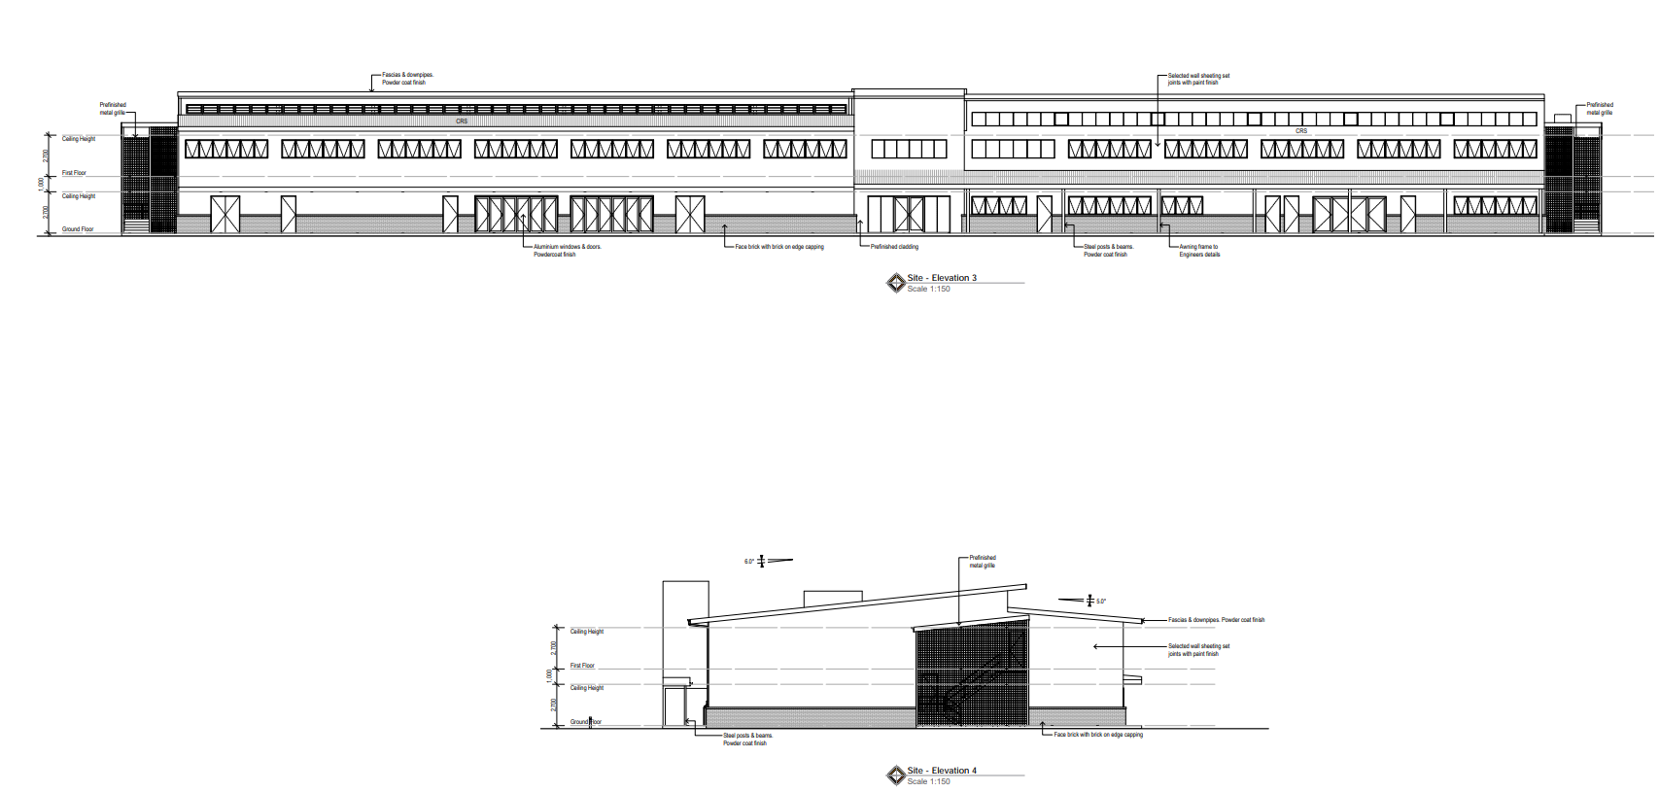
Plan 2: Northern and Western Elevation Plan, 30 October 2024

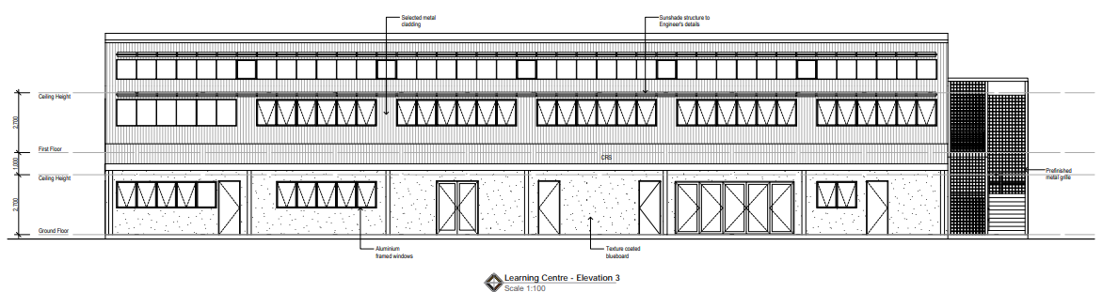
Plan 3: Learning Centre Southern Elevation Plan, 30 October 2024

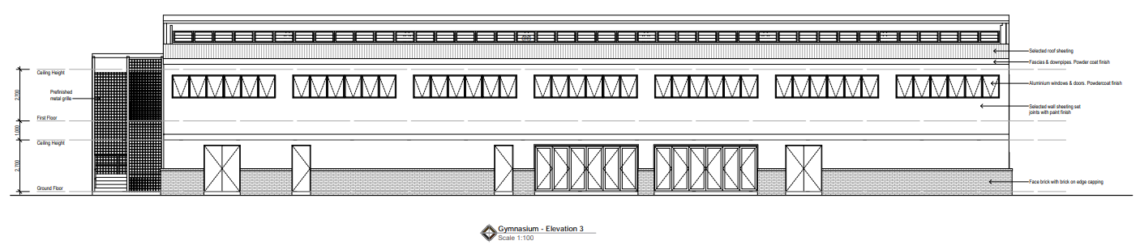
Plan 4: Gymnasium Southern Elevation Plan of the development, 30 October 2024

2.2 Background

The development application was lodged on 18 March 2024. A chronology of the development application since lodgement is outlined below including the Panel’s involvement (briefings, deferrals etc) with the application:
Table 1: Chronology of the DA
Date | Event
18 March 2024 | DA lodged
21 March 2024 | Exhibition of the application to surrounding properties and to External Government Authorities
25 March 2024 | WaterNSW requested additional information relating to stormwater.
12 April 2024 | Transport for NSW requested additional information relating to the anticipated traffic impacts generated by the development.
16 April 2024 | Department of Education required a concurrence checklist to be undertaken.
2 May 2024 | Rural Fire Service Determination received.
6 May 2024 | Concurrence checklist for the Department of Education was undertaken and submitted by the applicant.
6 May 2024 | Electronic Stormwater Music Model submitted by the applicant.
7 June 2024 | Council requested additional Information from the applicant relating to:  - Likely Impacts of the Development,  - Built Environment,  - Social Impacts,  - Landscape Plan,  - Vehicle Access/Traffic and Carparking,  - Stormwater,  - Geotechnical Report,  - Flood Impact Statement,  - Retaining Wall Plan and Elevations,  - Preliminary Site Investigation,  - Submissions.
12 June 2024 | Email from Council to the Applicant indicating outstanding information for assessment.
18 June 2024 | WaterNSW requested additional information relating to clarification for the Water Cycle Management Study.
19 June 2024 | Water Cycle Management Study submitted by the applicant, including General Arrangement Plan.
3 July 2024 | Transport for NSW again requested additional information relating to the anticipated traffic impacts generated by the development.
17 July 2024 | Advice received from WaterNSW.
3 August 2024 | The applicant submitted Preliminary Site Investigation Report and Flood Impact Assessment.
6 August 2024 | A letter clarifying Council’s concerns relating to permissibility was submitted by the applicant.
12 September 2024 | Council requested second (2nd) additional Information from the applicant relating to:  - Likely Impacts of the Development,  - Built Environment,  - Social Impacts,  - Landscape Plan,  - Vehicle Access/Traffic and Carparking,  - Stormwater,  - Geotechnical Report,  - Flood Impact Statement,  - Retaining Wall Plan and Elevations,  - Earthworks Plan,  - Preliminary Site Investigation,  - Compliance with Council’s Development Control Plan 2021,  - Compliance with Transport for NSW requirements,  - Community Concerns.
13 September 2024 | The applicant submitted an amended Geotechnical Report.
16 September 2024 | The applicant submitted the following documentation:  - Security Fencing Brochure,  - Amended Landscaping Plans,  - Retaining Wall Plan and Elevations.
23 September 2024 | The applicant submitted an amended Earthworks plan.
10 October 2024 | The applicant submitted the following documentation:  - Amended Site Plan showing road signage,  - Traffic and Parking Impact Assessment,  - Carpark Certification,  - Vehicle Swept Path Plans.
6 November 2024 | The applicant submitted the following documentation:  - External Render Plans and Colour Schedule,  - Amended Site Plan, Floor Plans, Site Elevations, Retaining Wall Setout Plan, Construction Details.  - Amended Preliminary Site Investigation with Targeted Sampling.  - Operational Manual.  - Revised Statement of Environmental Effects.
12 November 2024 | Panel Briefing.
16 December 2024 | Transport for NW requested additional information through the NSW Planning Portal.
17 February 2025 | A meeting was held between Council, the Applicant and Transport for NSW.
7 March 2025 | The applicant submitted additional information for Transport for NSW.
10 June 2025 | The applicant submitted a revised Road Safety Audit Report for Transport or NSW.
19 June 2025 | Transport for NSW provided a final response to the application.
1 July 2025 | Council re-requested additional information retaining to the stormwater management plan and drainage easement.
19 September 2025 | The applicant submitted the additional information for Council’s Development Engineer to assess.

  - Site History

The property was subdivided and registered in 1967 under the Blaxland Shire Council.

The site has since been vacant with no building structures.

- STATUTORY CONSIDERATIONS

  - Commonwealth Legislation

There is no commonwealth legislation that applies to this development.

  - Relevant State (NSW) Legislation

In addition to the EP&A Act, the following State (NSW) legislation is relevant and has been considered. Where relevant, further detailed assessment of the proposed development against the various Acts have been included throughout this report.

Biodiversity Conservation Act 2016 | Whilst the site contains some scattered vegetation along the boundaries, it does not form part of a biodiversity corridor and is located in a highly disturbed urban context. Accordingly, removal of the existing vegetation is unlikely to affect threatened species or ecological communities or their habitats according to the test in Section 7.3 and a BDAR is not required.
National Park and Wildlife Act 1974 | An AHIMS search did not identify any places of Aboriginal significance on the site or associated with the site.
Roads Act 1993 | The development is approximately 90m from the intersection of Magpie Hollow Road and The Great Western Highway, as such the development is defined as being a traffic generating development and requires approval from Transport for NSW.  Response from Transport for NSW was received 19 June 2025.
Contaminated Land Management Act 1997 | The property was previously utilised for the grazing of native vegetation and agricultural land uses as well as adjoining an existing service station.  As such a Preliminary Site Investigation was undertaken and determined that asbestos contamination was present in the vicinity of the buried dam. The review of the boreholes also identified the upper soil layers to comprise of natural top fill.  The asbestos detection appears to be localised at a single borehole location and therefore would need to be remediated during earthworks along with the previously imported fill.  The laboratory analysis also indicated that all other tested contaminants (along the western and eastern boundaries) were below the Site Assessment Criteria and does not exceed the risk to human health.  As such, Council is satisfied that subject to conditions on the consent relating to remediation works, the land can be made suitable for the proposed development.
Protection of the Environment Operations Act 1997 | The proposal does not trigger the requirement for an Environmental Protection Licence under the POEO Act.
Crown Land Management Act 2016 | The proposal does not impact any Crown Land.
Water Management Act 2000 | Water NSW has provided concurrence to the development subject to conditions of consent.
Biosecurity Act 2015 | The development is located within an urban area and therefore does not trigger the Biosecurity Act.
Conveyancing Act 1919 | The property does not contain any easements or restrictions on the title.

  - Part 4 Environmental Planning and Assessment Act, 1979

Matters for Consideration – General (Section 4.15)

When determining a development application, the consent authority must take into consideration the matters outlined in Section 4.15(1) of the Environmental Planning and Assessment Act 1979 (‘EP&A Act’). These matters as are of relevance to the development application include the following:

- the provisions of any environmental planning instrument, proposed instrument, development control plan, planning agreement and the regulations
(i) any environmental planning instrument, and
(ii) any proposed instrument that is or has been the subject of public consultation under this Act and that has been notified to the consent authority (unless the Planning Secretary has notified the consent authority that the making of the proposed instrument has been deferred indefinitely or has not been approved), and
(iii) any development control plan, and
(iiia) any planning agreement that has been entered into under section 7.4, or any draft planning agreement that a developer has offered to enter into under section 7.4, and
(iv) the regulations (to the extent that they prescribe matters for the purposes of this paragraph),
that apply to the land to which the development application relates,
- the likely impacts of that development, including environmental impacts on both the natural and built environments, and social and economic impacts in the locality,
- the suitability of the site for the development,
- any submissions made in accordance with this Act or the regulations,
- the public interest.

These matters are further considered below.

Integrated Development (Section 4.46)

The development is identified to be integrated development with regard to Section 4.46 -Rural Fires Act 1997 given that it is an educational establishment.

Local Infrastructure Contributions (Sections 7.12)
Section 7.12 of the Act states:

7.12 Fixed development consent levies

(1) A consent authority may impose, as a condition of development consent, a requirement that the applicant pay a levy of the percentage, authorised by a contributions plan, of the proposed cost of carrying out the development.

Council’s Local Infrastructure Contributions Plan (Section 7.12) 2024 applies to this development given it is for Educational Establishment (Private School) at an estimated cost of $10,817,262.00 (excluding GST).

Estimated cost of development | Levy applicable
$0 to $100,000 | 0%
$100,001 to $200,000 | 0.5%
$200,001 and over | 1%

As such, the following condition shall form part of the Development Consent:

Prior to the issue of a Construction Certificate the applicant shall pay to Council a Section 7.12 contribution of $108,172.62 in accordance with the Lithgow City Council Local Infrastructure Contributions Plan (Section 7.12) 2024. It is advised that the level of contribution in this plan may be adjusted at the time of actual payment, in accordance with the provisions of the Lithgow City Council Local Infrastructure Contributions Plan (Section 7.12) 2024.

  - Environmental Planning Instruments, proposed instrument, development control plan, planning agreement and the regulations

The relevant environmental planning instruments, proposed instruments, development control plans, planning agreements and the matters for consideration under the Regulation are considered below.

- Section 4.15(1)(a)(i) - Provisions of Environmental Planning Instruments

The following Environmental Planning Instruments are relevant to this application:

- State Environmental Planning Policy (Biodiversity & Conservation) 2021,
- State Environmental Planning Policy (Planning Systems) 2021,
- State Environmental Planning Policy (Resilience & Hazards) 2021,
- State Environmental Planning Policy (Transport and Infrastructure) 2021,
- Lithgow Local Environmental Plan 2014 (LLEP2014) and
- The Lithgow Development Control Plan 2021.

A summary of the key matters for consideration arising from these State Environmental Planning Policies are outlined in Table 3 and considered in more detail below.

Table 1: Summary of Applicable Environmental Planning Instruments

EPI | Matters for Consideration | Comply (Y/N)
State Environmental Planning Policy (Biodiversity and Conservation) 2021 | Chapter 6: Water Catchments  The development site is located within the Sydney Drinking Water Catchment.  The development was referred to the Water NSW with a satisfactory response received. | Yes
State Environmental Planning Policy (Planning Systems) 2021 | Chapter 2: State and Regional Development  Section 2.19(1) declares the proposal to be regionally significant development under Clause 5 of Schedule 6.  Clause 5: Private infrastructure and community facilities over $5 million  (b) affordable housing, child care centres, community facilities, correctional centres, educational establishments, group homes, health services facilities or places of public worship. | Yes
SEPP (Resilience & Hazards) | Council is satisfied that the land can be remediated in accordance with Chapter 4 subject to conditions on the consent. | Yes
State Environmental Planning Policy (Transport and Infrastructure) 2021 | Chapter 2: Infrastructure  - Subdivision 2 Development likely to affect an electricity transmission or distribution network  - Section 2.48(2) (Determination of development applications—other development) – electricity transmission - the proposal satisfies this section, subject to recommended conditions.  - Subdivision 2 Development in or adjacent to road corridors and road reservations  - Section 2.122 Traffic-generating development  Chapter 3: Educational Establishments and Child Care Facilities  - Part 3.4 Schools-Specific Development Controls  - Section 3.36 School-development permitted with Consent  - Part 3.7 General Development Controls  - Section 3.58 Traffic Generating Development  Schedule 8 Design Quality Principles in Schools-Chapter 3 | Yes
Lithgow Local Environment Plan 2014 | - Clause 2.3 – Zone Objectives and Land Use Table  - Clause 7.1 – Consideration of earthworks  - Clause 7.3 – Stormwater management  - Clause 7.5 - Groundwater Vulnerability  - Clause 7.10 Essential services | Yes
Lithgow Development Control Plan 2021 | - Chapter 2 – Site Requirements  - Chapter 3 – Environment and Hazards  - Chapter 7 – Commercial, Community & Industrial Development (including Advertising/Signage) | Yes.

Further considerations of the relevant SEPPs are outlined in more detail below:

State Environmental Planning Policy (Biodiversity and Conservation) 2021

Chapter 6: Water Catchments

Clause 6.1 of State Environmental Planning Policy (Biodiversity and Conservation) 2021 applies to the development because the site is located within the Sydney Drinking Water Catchment.

Part 6.2 of chapter 6 lists several controls that must be considered when a development is within a regulated catchment. As such, the development was referred to Water NSW. Water NSW provided that the following comments:
‘The subject property, which has been inspected by Water NSW, is located within the Warragamba catchment which forms part of Sydney's water supply.
Water NSW considered the following documents in its assessment of the application:

• Statement of Environmental Effects prepared by Anthony Daintith Town Planning Pty Ltd (dated 7/2/2024)
• Architectural Plans prepared by Brett Moulds Design and Drafting (dated 25/01/24), and
• The following documents prepared by Calare Civil Pty Ltd:
o Water Cycle Management Study, General Arrangement Plan including updated Stormwater Management Configuration and associated MUSIC Stormwater Quality Modelling (various dates), and
o Flood Impact Statement (dated 8 July 2024).

Water NSW notes the following from its assessment:

• the subject site receives stormwater run-on from Magpie Hollow Road in the south, and from neighbouring properties to the west and east. Water NSW understands that upslope diversion will be included in the detailed design stage to ensure this stormwater is diverted around the proposed development and associated stormwater management measures.
• the existing roadside drainage along Magpie Hollow Road will be retained, and the proposed site access will incorporate driveway crossovers to be appropriately designed during the detailed design stage.
• a stormwater drainage easement is proposed through Lot 21 DP 816671 located north of the subject site in agreement with the landholder. The drainage line shall be designed to convey stormwater from the subject site for a 1% AEP event, discharging into Council’s existing stormwater network on Kirkley St, and
• a portion along the northern boundary of the site is likely to experience minor inundation during a Probable Maximum Flood (PMF) event, as per the Flood Impact Statement. Water NSW understands that management measures shall be undertaken such that the inundation will not impact the proposed facility and the neighbouring properties to the north.

The above matters are addressed in conditions on the consent.
Based on the site inspection and the information provided, Water NSW considers that the proposed development can achieve a neutral or beneficial effect (NorBE) on water quality provided appropriate conditions are included in any development consent and are subsequently implemented.
Water NSW concurs with Council granting consent to the application subject to conditions.

State Environmental Planning Policy (Planning Systems) 2021 (‘Planning Systems SEPP’)

Chapter 2: State and Regional Development

As the development is an educational establishment with an estimated development cost of more than $5m it is identified as a ‘regionally significant development’ under section 2.19(1) and clause 5 of Schedule 6 of the Planning Systems SEPP. Accordingly, the Western Regional Panel is the consent authority for the application.

State Environmental Planning Policy (Resilience and Hazards) 2021

Chapter 4: Remediation of Land

The site was previously utilised for grazing and agricultural land uses. Additionally, the site adjoins an existing service station. The EPA’s “Managing Land Contamination” guideline recommends that land used for an industry listed in Appendix A of the Guideline is to be investigated prior to a change of use.

As such a Preliminary Site Investigation was undertaken and submitted with the application dated 3 August 2024. The Preliminary Site Investigation states:

5.1 Discussion
Uncertainties regarding the backfilled dam, the indistinguishable object along the western boundary, and the potential for surface soil contamination from fuel spill surface run-off along the eastern boundary should be investigated by undertaking limited targeted soil sampling.

Given that above comment and recommendation in the report, Council requested that a more detailed contamination investigation be undertaken with the report submitted to Council for assessment.

A further Preliminary Site Investigation report, with targeted sampling, dated 4 November 2024 was undertaken and determined that asbestos contamination was present in the vicinity of the buried dam. The review of the boreholes also identified the upper soil layers to comprise of natural top fill.

The asbestos detection appears to be localised at a single borehole location and therefore would need to be remediated during earthworks along with the previously imported fill.

The laboratory analysis also indicated that all other tested contaminants (along the western and eastern boundaries) were below the Site Assessment Criteria and does not exceed the risk to human health.

As such, Council is satisfied that subject to conditions on the consent relating to remediation works, the land can be made suitable for the proposed development.

State Environmental Planning Policy (Transport and Infrastructure) 2021

Chapter 2: Infrastructure

Section 2.48(2) (Determination of development applications—other development) – electricity transmission - the proposal satisfies this section, subject to recommended conditions.

The development was referred to Endeavour Energy who has no objection to the application subject to conditions placed on the consent.

Section 2.122 Traffic-generating development - Development in or adjacent to road corridors and road reservations

The development was referred to Transport for NSW who has no objection to the application subject to recommendations for conditions placed on the consent.

Chapter 3: Educational Establishments and Child Care Facilities
Section 3.36 School-development permitted with Consent - Part 3.4 Schools-Specific Development Controls

Clause 3.36 states:

Development for the purpose of a school may be carried out by any person with development consent on land in a prescribed zone.

(Note: clause 3.34 defines a “prescribed zone” and includes R2 low density residential as a prescribed zone.)
…
(6) Before determining a development application for development of a kind referred to in subsection (1), (3) or (5), the consent authority must take into consideration—
(a) the design quality of the development when evaluated in accordance with the design quality principles set out in Schedule 8, and
(b) whether the development enables the use of school facilities (including recreational facilities) to be shared with the community.

Clause 3.7

As such the development is permissible. The design principles are set out below.

- Part 3.7 General Development Controls
- Section 3.58 Traffic Generating Development

(1) This section applies to development for the purpose of an educational establishment—
(a) that will result in the educational establishment being able to accommodate 50 or more additional students, and
(b) that involves—
(i) an enlargement or extension of existing premises, or
(ii) new premises,
on a site that has direct vehicular or pedestrian access to any road.

As such the development was referred to Transport for NSW for assessment.

Schedule 8 Design Quality Principles in Schools-Chapter 3

These principles are also referred to in the Design Guide for Schools-Government Architect New South Wales, 2018. This document is a design guide for new school development and upgrades in NSW and that originally accompanied the previous Education SEPP, the State Environmental Planning Policy (Educational Establishments and Child Care Facilities) 2017 (Education SEPP).

Principle | Design Quality | Assessment
Principle 1 —context, built form and landscape | Schools should be designed to respond to and enhance the positive qualities of their setting, landscape and heritage, including Aboriginal cultural heritage. The design and spatial organisation of buildings and the spaces between them should be informed by site conditions such as topography, orientation and climate.  Landscape should be integrated into the design of school developments to enhance on-site amenity, contribute to the streetscape and mitigate negative impacts on neighbouring sites.  School buildings and their grounds on land that is identified in or under a local environmental plan as a scenic protection area should be designed to recognise and protect the special visual qualities and natural environment of the area, and located and designed to minimise the development’s visual impact on those qualities and that natural environment. | The property is not identified to contain aboriginal cultural heritage as per the Aboriginal Heritage Information Management System (AHIMS).  The property is currently vacant with vacant land adjacent to the development; however, approved for a residential subdivision, and adjoins a service station and residential developments.  The school building is proposed to contain a setback of 33m from the front southern boundary, behind the proposed carparking area, 20m from the adjoining western boundary, 18m from the rear northern boundary and 41.8m from the adjoining eastern boundary.  As such, the development contains adequate setbacks to have no impact in terms of overshadowing or privacy to the adjoining properties.  The development proposes one main building consisting of two storeys and an orientation of a frontage to the street. The building is proposed to be located approximately within the middle of the property with landscaping and other infrastructure around the building.  The architectural design of the building includes the front facade of the building to contain timber batons, stepped out entry, different levelled roofing and natural tones/brickwork. This will help the visual streetscape by breaking the front wall elevation from being one straight orientation and a large rectangular building. The design and architectural details of the building would further help the development to look and feel like a school for the younger generation to attend.  The scale and massing of the development is considered to be much larger than developments on adjoining and adjacent land; however given the setbacks for the building and design of the development, it is expected that this will not be apparent from the streetscape.  Landscaping has been integrated into the design of the development with different types of species proposed to be planted around the boundaries of the property, throughout the carparking area and around the school outside playground area.  Some types of species proposed includes:  - Banksia marginata and integrifolia,  - Eucalyptus scorparia, pulverulenia and pauciflora,  - Melalueca bracteate,  - Photenia,  - Allocasuarina,  - Callistemon,  - Chinese Elm,  - Acacia Decora,  - Manchurian Pear,  - Wild Iris,  - Gleditsia ‘Sunburst’,  - Lomandra Tanika border plants.  The amount, location and type of landscaping is considered to enhance the on-site amenity, contribute to the streetscape by softening the visual appearance and will help to mitigate impacts to neighbouring properties, specifically in terms of noise and visual impacts.  The proposed landscaping plan is shown in the image below:  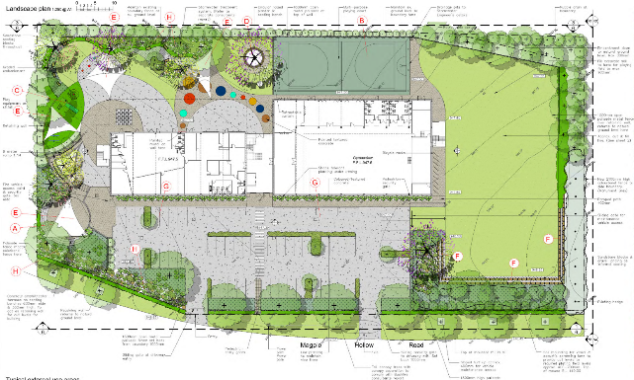  The property is not identified in or under a local environmental plan as a scenic protection area.  As such the development is considered to satisfactory comply with the design principle relating to the context, built form and landscape.
Principle 2—sustainable, efficient and durable | Good design combines positive environmental, social and economic outcomes. Schools and school buildings should be designed to minimise the consumption of energy, water and natural resources and reduce waste and encourage recycling.  Schools should be designed to be durable, resilient and adaptable, enabling them to evolve over time to meet future requirements. | The development has been designed to comply with Section J, as the development is proposed to contain windows and large open entries to allow natural ventilation via airflow and sunlight.  The school will be connected to available to reticulated services including constructing a stormwater treatment system.  An operational management plan has been submitted with the application and states that general waste and recycling bins will be placed around the campus/playground. The bins will be collected and emptied daily into a waste compound area. This would be managed by an employed cleaner and removed offsite by a waste contractor.  In relation to social and economic outcomes, it is to be noted that The Trustee for Katoomba Education Trust (developers) currently operate a school (known as OneSchool Global) in Mount Victoria (Blue Mountains Local Government area). This school is proposed to be closed should the current application be approved and constructed due to an increase in participants and the need for a larger facility. The school at Mount Victoria was previously utilised as a community hall.  Therefore, the development is expected to provide additional employment (during construction and once operational), housing and an increase in population to the Lithgow Local Government Area. As such the development would create a positive economic and social impact.  There is the potential for the design of the development to be adaptable and enable it to evolve overtime to meet future requirements. This may include building expansion, different materials or include energy/water efficiency requirements.  The development therefore is considered to comply with the principles relating to sustainable, efficient and durable.
Principle 3—accessible and inclusive | School buildings and their grounds should provide good wayfinding and be welcoming, accessible and inclusive to people with differing needs and capabilities. | The proposed development will achieve ease of access to people with different needs and capabilities by providing accessible parking areas, footpaths between the carparking and entry to the building as well as around the site, a lift within the building, accessible bathrooms and room entries.  The development will provide a secure entry to the site and building by proving fencing around the boundaries with lockable gates. This also helps with crime prevention measures.  The design and layout of the building is clear and helps to direct people around the development site, i.e. the entry/administration to the building is clear as it is proposed to be oriented forward from the classrooms.  The landscaping and open space areas also contributes to the enhancement and experience of the facility.  The location of the outdoor playground is located behind the main building away from the carparking area, this helps to create a safe environment. As well as the location of outdoor seating areas being spatially set out to support accessibility.  The school proposes in indoor gymnasium science labs and outdoor multi-purpose i.e. basketball court, that could be shared with the community and cater for activities outside of school hours.  It is therefore considered that the development complies with the design principles for accessible and inclusive.
Principle 4—health and safety | Good school development optimises health, safety and security within its boundaries and the surrounding public domain, and balances this with the need to create a welcoming and accessible environment. | As previously detailed above, it is considered that the development will propose adequate safety measures through landscaping, fencing, building orientation/design and the location of the outdoor infrastructure.
Principle 5—amenity | Schools should provide pleasant and engaging spaces that are accessible for a wide range of educational, informal and community activities, while also considering the amenity of adjacent development and the local neighbourhood.  Schools located near busy roads or near rail corridors should incorporate appropriate noise mitigation measures to ensure a high level of amenity for occupants.  Schools should include appropriate, efficient, stage and age appropriate indoor and outdoor learning and play spaces, access to sunlight, natural ventilation, outlook, visual and acoustic privacy, storage and service areas. | Amenity is provided by appropriate and efficient indoor and outdoor learning spaces, access to sunlight, natural ventilation, outlook, visual and acoustic privacy, storage, service areas and ease of access for all age groups and degrees of mobility.  As detailed previously in this table, the different spaces within the development would allow for informal and community activities to be undertaken.  The development is within proximity to the Great Western Highway, while adjoining a busy service station. The development contains appropriate setbacks from boundaries and landscaping around the site that would decrease potential noise impacts from the highway and service station.  It is considered that the development has been designed to suit the amenity principles.
Principle 6—whole of life, flexible and adaptive | School design should consider future needs and take a whole-of-life-cycle approach underpinned by site wide strategic and spatial planning. Good design for schools should deliver high environmental performance, ease of adaptation and maximise multi-use facilities. | The school provides for learning from kindergarten to Year 12.  As previously stated in this table, the school has been designed to take in future needs and requirements.  The facility can be utilised for a number of uses specially the gymnasium and science labs as well as the large carparking area.  With a new proposed residential subdivision adjacent to the development, and the size of the facility, the development would provide a venue for community activities and social events.  As such, the development would allow for flexibility and could be utilised for an adaptive reuse in the future.
Principle 7—aesthetics | School buildings and their landscape setting should be aesthetically pleasing by achieving a built form that has good proportions and a balanced composition of elements. Schools should respond to positive elements from the site and surrounding neighbourhood and have a positive impact on the quality and character of a neighbourhood.  The built form should respond to the existing or desired future context, particularly, positive elements from the site and surrounding neighbourhood, and have a positive impact on the quality and sense of identity of the neighbourhood. | As previously stated in this table, the development proposes adequate landscaping by providing a different variety of species to be spatially located throughout the site.  The amount, location and type of landscaping is considered to enhance the on-site amenity, contribute to the streetscape by softening the visual appearance and will help to mitigate impacts to neighbouring properties, specifically in terms of noise and visual impacts.  The architectural design of the building includes the front facade of the building to contain timber batons, stepped out entry, different levelled roofing and natural tones/brickwork. This will help the visual streetscape by breaking the front wall elevation from being one straight orientation and a large rectangular building. The design and architectural details of the building would further help the development to look and feel like a school for the younger generation to attend.  The development therefore adequately responds to the aesthetic principles.

Lithgow Local Environmental Plan 2014

The relevant local environmental plan applying to the site is the Lithgow Local Environmental Plan 2014 (‘the LEP’). The aims of the LEP include:

(aa) to protect and promote the use and development of land for arts and cultural activity, including music and other performance arts,

(a) to encourage sustainable and planned development that complements the unique character and amenity of Lithgow and enhances its towns, villages and rural areas,

(b) to provide for a range of development opportunities that contribute to the social, economic and environmental resources of Lithgow in a way that allows the needs of present and future generations to be met by implementing the principles of ecologically sustainable development,

(c) to manage, facilitate and encourage sustainable growth and development that—

(i) promotes the efficient and effective delivery of utilities, infrastructure and service and minimises long-term costs to government, authorities and the community, and

(ii) protects, enhances and conserves mineral and extractive resources lands, forests and agricultural lands and the contributions they make to the local, regional and State economy, and
(iii) allows for the orderly growth of land uses while minimising conflict between land uses in a zone and land uses in adjoining zones, and

(iv) encourages a range of housing choices in planned urban and rural locations to meet population growth and the diverse needs of the community, and

(v) preserves and protects land that has been identified for future long-term urban development from inappropriate fragmentation and development, and

(vi) protects and enhances environmentally sensitive areas, ecological systems, areas of high scenic, recreational, landscape or conservation value and areas that have the potential to contribute to improved environmental outcomes, and

(vii) protects and enhances places and items of environmental, archaeological, cultural or heritage significance, including Aboriginal relics and places, and

(viii) avoids or minimises the impact of development on drinking and environmental water catchments to protect and enhance water availability and safety for human consumption and the maintenance of environmental and recreational values, and

(ix) strengthens and promotes employment land opportunities and appropriate tourism development and growth, and

(x) creates resilience to natural hazards through local land use planning.

The proposal is consistent with these aims as the proposal will contribute to the economic well-being of the community, in a socially and environmentally responsible manner and strengthen the position of Lithgow by encouraging employment and economic growth.

Zoning and Permissibility
The proposal is located within the R2 Low Density Residential land use zones under Clause 2.3 of the Lithgow Local Environmental Plan 2014 (LLEP2014).

The development is defined as being an educational establishment under the Lithgow LEP 2014.

Definition
educational establishment means a building or place used for education (including teaching), being—
(a) a school, or
(b) a tertiary institution, including a university or a TAFE establishment, that provides formal education and is constituted by or under an Act.

Figure 4 below shows the LLEP2014 zoning map of the property:
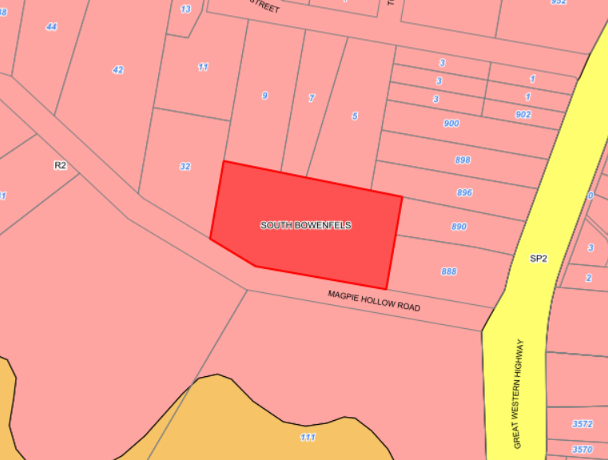
Plan 4: Zoning map (LLEP2014)

The zone objectives include the following (pursuant to the Land Use Table in Clause 2.3):

Zone | Objectives of zone
R2 – Low Density Residential | • To provide for the housing needs of the community within a low density residential environment.  • To enable other land uses that provide facilities or services to meet the day to day needs of residents.  • To maintain or improve the water quality of receiving water catchments.

The development is considered to be consistent with the zone objectives as:

- The proposed development provides a facility and service to meet youth educational requirements. Although the proposed development being a private school, the development will be specialised to meet the day to day needs of different ethnic and cultural backgrounds. This will further bring families and employment to the Lithgow region.
- The development is located within an existing residential built area and as such all services are existing. The development is not expected to impact the services as private vehicles would be utilised were possible for safety purposes.
- The development has been adequately designed with stormwater models and infrastructure. This has been assessed by WaterNSW and is found to be satisfactory.

General Controls and Development Standards (Part 7)

The LEP 2014 contains controls relating to development standards, miscellaneous provisions and local provisions. The controls relevant to the proposal are considered below.

Control | Requirement | Proposal | Comply
Earthworks (Cl 7.1) | In deciding whether to grant development consent for earthworks (or for development involving ancillary earthworks), the consent authority must consider the following matters—  - the likely disruption of, or any detrimental effect on, drainage patterns and soil stability in the locality of the development,  - the effect of the development on the likely future use or redevelopment of the land,  - the quality of the fill or the soil to be excavated, or both,  - the effect of the development on the existing and likely amenity of adjoining properties,  - the source of any fill material and the destination of any excavated material,  - the likelihood of disturbing relics,  - the proximity to, and potential for adverse impacts on, any waterway, drinking water catchment or environmentally sensitive area,  - any appropriate measures proposed to avoid, minimise or mitigate the impacts of the development,  - the proximity to, and potential for adverse impacts on, any heritage item, archaeological site or heritage conservation area. | The development proposes a maximum of approximately 1.5m of fill (majority to be located towards the north/rear of the development project area) and approximately 1m of cut around the southern/front section of the development (carparking and part of the built site).  1.5m High sandstone block retaining walls are proposed to be constructed around the south eastern corner and south western corner of the property for containment of soils.  The proposed development will have minimal impacts on drainage patterns and soil stability in the locality through construction in accordance with the stormwater management plan.  Conditions of consent have been imposed to ensure dust, noise and erosion impacts are minimised during works and in perpetuity as a result of the earthworks.  In addition, earthworks are proposed to be undertaken as a result of contamination from asbestos and previous fill to a dam. Refer to sections in this report relating to contamination for more details.  Conditions of consent will also be imposed to control erosion and sedimentation impacts on the site. | Yes
Stormwater Management (Cl 7.3) | In deciding whether to grant development consent for stormwater management, the consent authority must consider the following matters—  - is designed to maximise the use of water permeable surfaces on the land having regard to the soil characteristics affecting on-site infiltration of water, and  - includes, if practicable, on-site stormwater retention for use as an alternative supply to mains water, groundwater or river water, and  - avoids any significant adverse impacts of stormwater runoff on adjoining properties, native bushland and receiving waters, or if that impact cannot be reasonably avoided, minimises and mitigates the impact. | Currently, there are no formal stormwater management measures at the site with runoff draining to the north towards Kirkley Street via uncontrolled overland flows. As part of the development, a new pit and pipe network is to be constructed to capture all runoff from the roof and hardstand areas, discharging into the existing network in Kirkley Street.  In order to achieve this, the new stormwater line and easement is proposed through Lot 21 DP 816671.  A stormwater management plan was submitted with the application and demonstrates irrigation systems, rainwater tanks and a bio-retention system to be utilised for the development.  The stormwater management has been assessed against the WaterNSW water quality guidelines and Norbe Assessment.  The development was referred to WaterNSW who has given concurrence subject to conditions on the consent.  The development was also assessed by Council’s Engineers who considers the development to have adequate drainage. | Yes
Groundwater Vulnerability (Cl 7.5) | In deciding whether to grant development consent for development on land to which this clause applies, the consent authority must consider the following—  (a) the likelihood of groundwater contamination from the development (including from any on-site storage or disposal of solid or liquid waste and chemicals),  (b) any adverse impacts the development may have on groundwater dependent ecosystems,  (c) the cumulative impact the development may have on groundwater (including impacts on nearby groundwater extraction for a potable water supply or stock water supply),  (d) any appropriate measures proposed to avoid, minimise or mitigate the impacts of the development. | Complies - The property is identified as containing ground water vulnerability. Groundwater dependent ecosystems would not be impacted upon by the development as measures will be undertaken to remediate the land from contaminants  The development is designed, sited and will be managed to avoid any significant adverse environmental impact. | Yes
Essential Services  (Cl 7.10) | Development consent must not be granted to development unless the consent authority is satisfied that any of the following services that are essential for the development are available or that adequate arrangements have been made to make them available when required—  the supply of water,  the supply of electricity,  the disposal and management of sewage,  stormwater drainage or on-site conservation,  suitable vehicular access. | Vehicular access to the site will be provided via Magpie Hollow Road, upgraded in accordance with Council’s Engineering requirements.  The development will be connected to water, electricity and sewer. Stormwater will discharge to via drainage pit to the north of the site.  As such, the development will have all essential services as required and complies with Cl 7.10. | Yes

The proposal is considered to be generally consistent with the LEP.

- Section 4.15 (1)(a)(ii) - Provisions of any Proposed Instruments

There are several proposed instruments which have been the subject of public consultation under the EP&A Act. Those relevant to the proposal, include the following:

- Draft Remediation of Land SEPP

A proposed Remediation of Land State Environmental Planning Policy ('Remediation of land
SEPP'), that was exhibited from 31 January to 13 April 2018, is currently under consideration by the NSW Department of Planning. The proposed Remediation of Land SEPP is intended to repeal and replace the provisions of SEPP 55 (now Chapter 4 of SEPP (Resilience and Hazards) 2021) and Contaminated Land Planning Guidelines. The SEPP seeks to provide a state-wide planning framework to guide the remediation of land, including; outlining provisions that require consent authorities to consider the potential for land to be contaminated when determining development applications; clearly list remediation works that require development consent; and introducing certification and operational requirements for remediation works that may be carried out without development consent.

The Remediation of Land SEPP is aimed at improving the assessment and management of land contamination and its associated remediation practices. The proposal is consistent with the draft provisions and is considered to be acceptable subject to conditions of consent having been assessed in detail against the current provisions of SEPP (Resilience and Hazards) 2021.

The proposal therefore is generally consistent with the proposed instrument.

- Section 4.15(1)(a)(iii) - Provisions of any Development Control Plan

Section 4.15(1)(a)(iii) of the EP&A Act requires Council to consider the provisions of any development control plans.

The development has been assessed having regard to the relevant desired outcomes and prescriptive requirements within the Lithgow Development Control Plan 2021 (LDCP2021).

Lithgow Development Control Plan 2021

LDCP2021  Clause | Requirement | Assessment Comments | Compliance
Chapter 2 – Site Requirements | Site Analysis demonstrates that the design of the proposed development has responded to an analysis of the site and its relevant context. | The development complies with the land use zone and its objectives.  The development has been designed to minimise potential impacts to surrounding landuses where possible, specifically in relation to setback, visual, overshadowing, privacy, traffic, noise and to minimise potential earthworks.  Surrounding development consists of a mixture of individual dwellings, a service station and a future residential subdivision. As such the development has been designed (in terms of setbacks and scale) to be consistent with the streetscape.  The size of the development is considered to be suitable for the land size.  The property will contain safe access to and from the site from Magpie Hollow Road.  There are no heritage items located within the vicinity of the site. The development further has been assessed in accordance to bushfire requirements. | Yes
2.2 Site Analysis, Local Character and Context |  |  | Yes
2.2.2 Site Analysis & Development Response |  |  | Yes
2.2.3 Local Character & Context | Character: All applications demonstrate that the proposed development has considered the local existing and desired future character of the area and that the proposed development is consistent with and/or integrates with this character. | The property is currently vacant with vacant land adjacent to the development; however, approved for a residential subdivision, and adjoins a service station and residential developments.  The school building is proposed to contain a setback of 33m from the front southern boundary, behind the proposed carparking area, 20m from the adjoining western boundary, 18m from the rear northern boundary and 41.8m from the adjoining eastern boundary.  As such, the development contains adequate setbacks to have no impact in terms of overshadowing or privacy to the adjoining properties.  The development proposes one main building consisting of two storeys and an orientation of a frontage to the street. The building is proposed to be located approximately within the middle of the property with landscaping and other infrastructure around the building.  The architectural design of the building includes the front facade of the building to contain timber batons, stepped out entry, different levelled roofing and natural tones/brickwork. This will help the visual streetscape by breaking the front wall elevation from being one straight orientation and a large rectangular building. The design and architectural details of the building would further help the development to look and feel like a school for the younger generation to attend.  The scale and massing of the development is considered to be much larger than developments on adjoining and adjacent land; however given the setbacks for the building and design of the development, it is expected that this will not be apparent from the streetscape.  Landscaping has been integrated into the design of the development with different types of species proposed to be planted around the boundaries of the property, throughout the carparking area and around the school outside playground area.  The approved residential subdivision adjacent to the property would allow for an additional 55 dwellings (approximately), with the closest existing school being approximately 5km from the site.  As such, it is considered that the development has been designed to suit the existing and future character of the area. | Yes
2.2.4 Visually Prominent Sites | Development on a visually prominent site, particularly in rural and/or environmental zones or in heritage conservation areas, is sited and designed to minimise visual and environmental impact. | The development site is not located on a visually prominent site. The development is to be located on the outskirts of the Lithgow/South Bowenfels township, on a main road thoroughfare to Lake Lyell camping and recreation park.  The development has been designed to contain a carpark in front of the main building with landscaping around the boundaries.  The architectural design of the building includes the front facade of the building to contain timber batons, stepped out entry, different levelled roofing and natural tones/brickwork. This will help the visual streetscape by breaking the front wall elevation from being one straight orientation and a large rectangular building.  The building will further be articulated with windows and doors, with no blank walls.  Adequate landscaping consisting of different species will be located throughout the development and that will help to soften the streetscape.  The development therefore complies with the DCP. | Yes
2.3 Slope Response, Earthworks & Retaining Walls | - Description: All development that involves any significant earthworks provides a plan and/or description of the location, extent and depth of earthworks that forms part of the application.  - LLEP2014: All development that involves any significant earthworks addresses Clause 7.1 - Earthworks of LLEP2014.  - Design: Developments on sloping sites are sited, designed and use construction techniques that respond to the topographical (slope) & hydrological (water) features of the site. Alternatives to slab on ground construction should be utilised where, due to gradient and characteristics of the site, such form of construction is inappropriate.  - Impact: Depending on the likelihood and significance of impact of any proposed earthworks on the matters raised in the objectives of this Section, Council may require justification for the need for those earthworks AND additional plans/reports/certification to demonstrate that the impacts can be avoided, mitigated or minimised (for examples, see table below).  - Drainage: Disturbance to natural drainage patterns is minimised and addresses Section 2.5 Stormwater Management of this DCP.  - Batters:  - Cut and fill batters do not exceed a slope of 1V:2H (vertical to horizontal) depending on soil classification or Council is satisfied of sufficient site stability by a Geo-technical and/or Structural Report; and  - All batters are to be provided with both short and long-term stabilisation to prevent soil erosion and do not extend onto public or adjoining land without permission. | The applicant has demonstrated through design plans, how the proposed development complies with the earthwork requirements including the need for potential retaining walls.  The development proposes a maximum of approximately 1.5m of fill (majority to be located towards the north/rear of the development project area) and approximately 1m of cut around the southern/front section of the development (carparking and part of the built site).  1.5m High sandstone block retaining walls are proposed to be constructed around the south eastern corner and south western corner of the property for containment of soils.  The proposed development will have minimal impacts on drainage patterns and soil stability in the locality through construction in accordance with the stormwater management plan.  Conditions of consent have been imposed to ensure dust, noise and erosion impacts are minimised during works and in perpetuity as a result of the earthworks.  In addition, earthworks are proposed to be undertaken as a result of contamination from asbestos and previous fill to a dam. Refer to sections in this report relating to contamination for more details.  Conditions of consent will also be imposed to control erosion and sedimentation impacts on the site. | Yes
2.3.1 Earthworks  2.3.2 Retaining Walls |  |  | Yes
2.4 Stormwater Management | - Application: Development applications (in accordance with Council's DA Guide) may need to provide a Stormwater Drainage (Concept) Plan (SDCP) and/or Soil and Water Management Plan (SWMP) addressing stormwater management on the Site.  - Guidelines: All Stormwater drainage is designed to comply with Council's Engineering Guidelines – Section 3 – Stormwater Drainage.  - Drinking Catchment: Unless there is 'no identifiable potential impact', all development within the Sydney Drinking Water Catchment demonstrates a neutral or beneficial effect upon water quality in accordance with the requirements of SEPP (Sydney Water Drinking Catchment) 2011. | Currently, there are no formal stormwater management measures at the site with runoff draining to the north towards Kirkley Street via uncontrolled overland flows. As part of the development, a new pit and pipe network is to be constructed to capture all runoff from the roof and hardstand areas, discharging into the existing network in Kirkley Street.  In order to achieve this, the new stormwater line and easement is proposed through Lot 21 DP 816671.  A stormwater management plan was submitted with the application and demonstrates irrigation systems, rainwater tanks and a bio-retention system to be utilised for the development.  The stormwater management has been assessed against the WaterNSW water quality guidelines and Norbe Assessment.  The development was referred to WaterNSW who has given concurrence subject to conditions on the consent.  The development was also assessed by Council’s Engineers who considers the development to have adequate drainage. | Yes
2.5 Vehicle Access and Parking | All development is e.g., designed to be consistent with (as amended):  - Council’s Guidelines for Civil Engineering Design and Construction for Development (2012) ('Engineering Guidelines').  - RTA (now Transport for NSW) (2002) Guide to Traffic Generating Developments; and  - Relevant Australian Standards including but not limited to (as amended):  - AS2890 – Parking facilities including:  - AS2890.1 (2004) – Off-street car parking.  - AS2890.2 (2018) – Off-street commercial vehicle facilities.  iii. AS2890.3 (2015) – Bicycle parking facilities.  iv. AS2890.6 (2009) – Off-street parking for people with disabilities  - AS1428 – Design for Access and Mobility.  - Relevant Austroads Guidelines; and  - Relevant Council Policies. | Vehicle access is proposed to be via a separate entry and exit from Magpie Hollow Road to a parking area. This access is considered to be satisfactory for the development in terms of site safety.  The driveway has been designed to respond to the topography of the land with minimal earthworks proposed to be undertaken.  The access has been undertaken in accordance with Council’s Engineering Guidelines.  The slope of the driveway contains a maximum 5% grade. This is below the 25% grade as stated in the DCP.  The total width of the entry and exit driveways is approximately 6.2m carriageway width. This complies with the minimum carriageway width.  A landscaping plan was submitted with the application and shows landscaping to be proposed around the carpark area and building site. | Yes
2.5.4 Parking Location, Design & Circulation | 1) Parking Location,  2) Parking Design,  3) Accessible Parking,  4) Safety,  5) Sealed Vehicle Areas,  6) Stormwater,  7) Vehicle Sizes,  8) Operating Hours,  9) Basement Parking,  10) Stacked Parking,  11) Circulation,  12) Parking Navigation,  13) Lighting,  14) Visual Impact | Parking is located at the front of the building. Screening via landscaping and retaining walls surround the carpark to minimise potential impact to adjoining property owners. The location of the carparking area further requires minimal earthworks and provides adequate drainage.  Parking design complies with Council’s Engineering Guidelines.  The carparking layout has been designed to minimise potential safety impacts around the site and enable adequate manoeuvring for all vehicles to leave the site in a forward direction.  Conditions would be applied to the consent to ensure the access to be sealed in accordance with Council’s Engineering Guidelines.  It is expected that the vehicle sizes to the site will be standard car sizes once operational with a small school bus.  The hours of operation for vehicles will majority be during daylight hours due to the nature of the development.  A carpark certification report was submitted with the application and is considered to adequately address Council’s DCP 2021. | Yes
2.5.5 On-Site Parking Numbers | The DCP states:  Secondary Schools: 1 space per staff member (peak staff level) + 1 space per 10 students (17 years of age or older) + adequate student set down/pick up areas, bus turning areas + parking for auditoriums and sportsgrounds | The carparking area is proposed to consist of 55 spaces, (including an accessible space, staff parking, and minivan parking) separate entry and exit from Magpie Hollow Road, drop off/pick up zone, pedestrian walkway, 2-way vehicle manoeuvring area and landscaping throughout.  The carparking area is proposed to be located in front of the building with security gates along the front and around the boundaries of the property.  As such, the number of car parking spaces to be provided for the development is considered satisfactory. | Yes
2.5.7 Bicycle Parking | 1 space per 15 car parking spaces | 24 bicycle parking spaces are proposed to be provided for the development. These spaces are to be located towards the western side of the building This is considered satisfactory. | Yes
2.6 Pedestrian Access, Mobility & Safety | Accessibility  1) Access to Premises Standards,  2) National Construction Code,  3) Australian Standards.  Pedestrians  - Separation,  - Entrances,  - Mixed-Use Buildings,  - Access Ramps,  - Lighting. | The development was assessed by Council’s Building Officer and found to be satisfactory for the development subject to conditions on the consent.  Pedestrian access to the development is accessible via the carparking area, with adequate lighting around the building and communal areas. | Yes
2.7 Designing for Crime Prevention | Crime Risk Assessment  Objective 1  To ensure that new larger developments and subdivisions (see table below), and/or significant alterations and additions to existing larger developments (see table below) has:  - Considered how it may improve safety and reduce the facilitation of criminal activity.  - Demonstrated how the design has responded to the four (4) main principles of crime prevention including: territorial re-enforcement, surveillance, access control and space/activity management to create the perception or reality of reduced opportunity for crime or inappropriate behaviour.  - Provided appropriate lighting that enhances safety and security whilst minimising impacts from light-spill or inappropriate lighting on neighbouring properties. | The development will contain a 1.8m high palisade fence around the site with security gates proposed for the driveway.  The design and orientation of the building will further allow natural surveillance from the windows, carparking and outdoor recreation areas.  The Statement of Environmental Effects states:  • After and before hours access is restricted by proposed gates.  • Proposed lighting will illuminate the building and car park.  •Strategic landscaping is proposed on the site to enable a place to hide an entrap victims.  • Proposed landscaping on the southern boundary to assist in the prevention of graffiti.  • The fencing (and gate) is of open steel construction.  This is satisfactory for the development and complies with the DCP. | Yes
2.8 Utilities, Easements & Infrastructure | 2.8.1 – Connections Utilities  2.8.2 – Building Near Utilities/Easements/Drainage Lines  2.8.6 – Water Supply | The development is proposed to be connected to Council’s water and sewer services.  The application has been assessed by Council’s Water and Wastewater Officer and is found to be suitable for the development subject to conditions on the consent.  Electricity, telecommunications and gas will also be connected to the development from Magpie Hollow Road.  The development will not be built over any easements with adequate setbacks. | Yes
2.9 Solid Waste Management | Waste Storage and Collection – Larger Developments | It is anticipated that waste generated during construction can be managed through standard construction measures. Once operational, general waste and recycling bins will be placed around the campus/playground.  A screened bin enclosure area/compound has also been allocated on the plans to be located east of the carpark.  The individual small bins are proposed to be collected/emptied daily to the compound by an employed cleaner who will monitor and manage waste.  The submitted operational manual further states that a waste contractor will be scheduled to attend the campus outside of the operation hours to empty the bins (7-8am or 3-5pm).  This is considered satisfactory for the development subject to suitable conditions being included on the consent should the application be approved, | Yes
Chapter 3 – Natural Environment and Hazards
3.2 Bush Fire Prone Land | Where a proposed development is on land identified as bush fire prone on the Bush Fire Prone Land Map, the design and management of any proposed development on that bush fire prone land complies with the following:  - Rural Fire Act 1997 (NSW) & the associated Rural Fires Regulation 2013 (as amended); and  - NSW Rural Fire Service (2019) Planning for Bush Fire Protection (Bush Fire Guidelines).  - Any development application involving the erection of a dwelling house or alterations and additions to an existing dwelling house on bush fire prone land addresses the requirements contained in:  - The NSW Rural Fire Service (RFS) publication titled “Building in Bush Fire Prone Areas Single Dwelling Applicants Kit” found on the RFS website (www.rfs.nsw.gov.au); and  - Australian Standard AS3959 – 2009 Construction of Buildings in Bush Fire Prone Areas (for any Construction Certificate application). A suitably qualified person may need to provide a schedule of compliance with the applicable construction standards. This schedule will form part of the approval documentation and the applicant will be required to comply with it during the course of construction; and  - National Construction Code (NCC) may specify additional controls for the construction of buildings on bushfire-prone lands. | Part of the property is mapped as being bushfire prone land.  Educational Establishments are defined as being ‘integrated development’ under S4.46 of the EP&A Act, therefore, the application was referred to the NSW Rural Fire Service for comment.  The NSW Rural Fire Service and Council consideration was assessed against the submitted Bushfire Assessment prepared by Bushfire Planning & Design; dated 2 February 2024.  The NSW RFS considered the information submitted and provided General Terms of Approval, under Division 4.8 of the Environmental Planning and Assessment Act 1979, and under section 100B of the Rural Fires Act 1997.  Conditions have been included for consent in this regard.  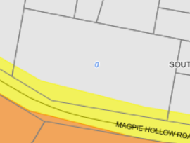 | Yes
3.3 Vegetation Management and Biodiversity |  | The property is not located within the Biodiversity mapped prone area. | N/A
3.4 Land and Soils | In order to satisfy the requirements of Clause 7.7 - Sensitive Lands, particularly subclause (4) that:  - The development is designed, sited and will be managed to avoid significant adverse environmental impact, or  - If that impact cannot be avoided—the development is designed, sited and will be managed to minimise that impact, or  - If that impact cannot be minimised—the development will be managed to mitigate that impact | The property is not located in the sensitive land area under the Lithgow LEP 2014.  Contamination:  The property was previously utilised for the grazing of native vegetation and agricultural landuses as well as adjoining an existing service station.  As such a Preliminary Site Investigation was undertaken and submitted with the application dated 3 August 2024. The plan stated:  5.1 Discussion  Uncertainties regarding the backfilled dam, the indistinguishable object along the western boundary, and the potential for surface soil contamination from fuel spill surface run-off along the eastern boundary should be investigated by undertaking limited targeted soil sampling.  Given that above comment and recommendation in the report, Council requested that a more detailed contamination investigation be undertaken with the report submitted to Council for assessment.  A further Preliminary Site Investigation report, with targeted sampling, dated 4 November 2024 was undertaken and determined that asbestos contamination was present in the vicinity of the buried dam. The review of the boreholes also identified the upper soil layers to comprise of natural topfill.  The asbestos detection appears to be localised at a single borehole location and therefore would need to be remediated during earthworks along with the previously imported fill.  The laboratory analysis also indicated that all other tested contaminants (along the western and eastern boundaries) were below the Site Assessment Criteria and does not exceed the risk to human health.  As such, Council is satisfied that subject to conditions on the consent relating to remediation works, the land can be made suitable for the proposed development. | Yes
3.4.1 Contaminated Land |  |  | Yes
3.4.2 Sensitive Lands |  |  | Yes
3.4.3 Erosion & Sedimentation |  |  | Yes
3.6 Ground & Surface Water Protection |  | Complies - The property is identified as containing ground water vulnerability. Groundwater dependent ecosystems would not be impacted upon by the development as measures will be undertaken to remediate the land from contaminants  The development is designed, sited and will be managed to avoid any significant adverse environmental impact. | Yes
Chapter 7 – Commercial, Community & Industrial Development (including Advertising/Signage)
Given that Council does not specifically have development controls for schools, Chapter 7 is used as a guide as it has similar functions to commercial premises.
7.1.2 Overarching Objectives | Objectives  - Contribute to economic growth and employment opportunities within the LGA;  - Capitalise on existing development and maximise the efficient use of public infrastructure;  - Respond to, reinforce and sensitively relate to the spatial and environmental characteristics of the surrounding urban environment;  4) Demonstrate good site planning, layout, functionality and amenity for users;  5) Conserve and enhance the historic, architectural and aesthetic character of urban areas (particularly in relation to heritage items and heritage conservation areas);  6) Reinforce, complement and enhance the desirable visual character of the street;  7) Integrate with and transition to neighbouring zones/lots/buildings; and  8) Preserve neighbourhood amenity and safety. | - The development during construction and once operational would contribute to employment opportunities and economic growth.  The development would service participants from Katoomba to Lithgow with the current school at Mount Victoria to close should the application be approved and constructed.  - The development proposes to be located adjoining new residential subdivisions in the South Bowenfels area and a future potential subdivision adjacent to the property. The development is also proposed to be located on the verge of the Lithgow residential zone, within proximity to the Great Western Highway. Other public infrastructure in the vicinity of the development involves water, sewer and stormwater services.  - The development has been designed to respond to the environmental characteristics by providing adequate setback from boundaries and landscaping around the site.  - The main school building is located approximately in the middle of the property to allow for carparking at the front and recreational/playground use at the back. This is functionally for the safety of the participants, traffic, landscaping and infrastructure service locations.  - The property is not heritage listed or adjoins any historical items. The architectural design of the development includes different building elements as well as landscaping features to suit the surrounding area.  - As previously stated, the development has been designed to complement and enhance the visual character of the streetscape by providing a new architectural building next to a service station that has existed for many years.  - The development is permissible in the residential zone and would be compatible with other zones should the zoning change in the future.  - The development has been designed to preserve neighbourhood amenity and safety by providing safety and security measures such as landscaping and fencing around the site and onsite carparking/bus zones. | Yes
7.2.1 Site Analysis & Potential Land Use Conflicts | Objectives  a) Complies with the Site Analysis requirements in DCP Chapter 2 – Site Requirements (including any other relevant chapters in this DCP & the DA Guide); and  b) Has responded to the Site Analysis to produce a high-quality design that minimises the potential for land use conflict and integrates with the surrounding site context. | The development complies with chapter 2, refer to previous comments above for more information. | Yes
7.2.2 Open (Outdoor) Storage, Utility, Waste & Service Areas | Controls  1) Location & Screening: a) Open (outdoor) storage areas and associated screening are identified on the Site Plan(s) for the development and may require Elevation(s) to show screening height, materials & transparency (particularly when visible from a public street);  b) Open storage areas are located behind the building line to any street frontage (preferably behind the building) and/or screened from view from the street.  2) Screening/Fencing:  a) Screening is compatible with the design of the building and integrated with the site landscaping and fencing.  b) Screening that forms part of, or is immediately adjacent to boundaries/fencing complies with the Fencing controls in this DCP.  - Landscaping: Landscaping is not used as the primary or only method for screening, unless it is well established or the applicant can demonstrate that the storage area will be effectively screened using advanced plantings in conjunction with fencing, and other screening devices.  - Hazardous Materials: The storage of hazardous goods, materials or wastes does not occur in areas that adjoin residential or other sensitive land-uses, unless screened from view and there are suitable protections to avoid impacts on adjoining sites.  - Dust: Open storage areas minimise dust impacts on neighbouring properties with ground surface treatment to minimise dust emissions from vehicle movements.  6) Loading/Unloading: Sufficient space is provided on-site for the safe loading and unloading of wastes. This activity is not to be undertaken on any public place or street. | - No outdoor storage areas are proposed except for waste storage which is proposed to be screened and located to adjoin the car parking area. As such, this is satisfactory for the development.  - The development will contain a 1.8m high palisade fence around the site with security gates proposed for the driveway. Landscaping is also proposed around the boundaries of the property and scattered throughout the site. This is considered to be adequate screening for the development.  - As previously stated, no storage areas except for the waste area which will be adequately screened by vegetation and an enclosure as well as being located towards the rear of the car carking area.  - It is expected that no hazardous material will be kept on site except for in the science lab however this will be located within the main school building.  - The waste disposal area will be full enclosed with lids.  - Sufficient space is provided within the carparking area for the loading/unloading of material during operations of the development. | Yes
7.2.3 Landscaping & Tree Protection | Objective(s)  O1. Retention: To encourage the retention of trees and other significant vegetation and integration of these features into the design of buildings and open spaces, particularly where vegetation is outside the proposed building footprint and is of ecological, aesthetic or cultural significance.  O2. Context: To provide landscaping that responds to the context and character of the area, the land use zone, view lines and land-marks, any existing street or locality planting scheme, the local climate, and the site characteristics.  O3. Amenity: To integrate landscaping with site and building design so it enhances amenity, privacy, screening and solar access/shading (as required) outcomes for the site and adjoining sites and responds to the layout and scale of the proposed built form.  O4. Arterial Roads: To ensure development fronting an arterial road (especially highways and regional roads) is suitably landscaped to soften the visual impact of development when viewed from these key transport routes.  O5. Screening: To use landscaping to soften the visual impact of larger buildings, large hardstand / car parking areas, or screen service and storage areas from public view.  O6. Safety: To consider how landscaping is integrated with built form to address principles in DCP Section 2.7 – Designing for Crime Prevention.  O7. Stormwater: To minimise stormwater run-off and hard paved areas and maximise water infiltration and deep soil landscaped area in accordance with Stormwater Management controls in this DCP.  O8. Bushfire: To manage landscaping so that it enhances environmental connectivity but does not increase the bush fire risk to properties.  O9. Stability: To use landscape to stabilise steeper slopes, earth mounds, and areas with erosion potential.  010. Suitability: To encourage landscaping and species selection that is native and non-invasive, low-maintenance, robust, suited to local soil and climatic conditions, and minimises water consumption.  011. Longevity: To ensure that development considers the long-term protection, maintenance, irrigation, and longevity of landscape to maximise chances of achieving the original design outcomes.  012.Utilities: To avoid planting locations and species that may impact on underground or aboveground utilities or buildings, including but not limited to: excavation, root penetration, water damage or ground-heave from irrigation or moisture levels, mature-height of species interfering with overhead power-lines, etc.  013.Fencing: To integrate fencing with landscape design.  014.Biodiversity: To consider how retention and enhancement of landscape can address the biodiversity policies of the NSW Government and Council and encourage sustainable development.  015.Temperature: To utilise landscaping to mitigate the increases in temperature associated with solar absorption into buildings and hard surfaces, particularly in denser urban areas. | O1, O2, 03, 04, O5 & O6. Landscaping has been integrated into the design of the development with different types of species proposed to be planted around the boundaries of the property, throughout the carparking area and around the school outside playground area.  Some types of species proposed includes:  - Banksia marginata and integrifolia,  - Eucalyptus scorparia, pulverulenia and pauciflora,  - Melalueca bracteate,  - Photenia,  - Allocasuarina,  - Callistemon,  - Chinese Elm,  - Acacia Decora,  - Manchurian Pear,  - Wild Iris,  - Gleditsia ‘Sunburst’,  - Lomandra Tanika border plants.  The amount, location and type of landscaping is considered to enhance the on-site amenity, contribute to the streetscape by softening the visual appearance and will help to mitigate impacts to neighbouring properties, specifically in terms of noise and visual impacts.  O7. The development proposes a mixture of hardstand and landscaped areas. The stormwater management plan has been assessed by WaterNSW and Council’s Engineer and is considered satisfactory for the development.  O8. The landscaping plan was undertaken in consideration with the bushfire requirements. Given that only a small section at the front of the property is within the bushfire prone area, the landscaping plan is considered to comply with the DCP and enhances the environment.  O9. Although, there are no steep slopes on the property, the landscaping has been placed where potential erosion may occur from the development. Ie. Around the boundaries of the property.  O10. The species selection is considered adequate for the Lithgow regions climate and the surrounding environment.  O11. The applicant has indicated within the Operational Management Plan that the landscaping would be managed and maintained by an employed gardener.  O12. The location of the utilities would not be impacted by the location of the landscaping.  O13. The proposed fencing around the property has been incorporated with the landscaped plans.  O14. The landscaping is considered to adequately address biodiversity policies.  O15. Landscaping has been placed around the site to provide adequate shading to the school playground and building. | Yes
7.2.4 Fencing | Objective(s)  Fencing is located and designed:  O1. To be consistent with the existing (or desired future) character of the relevant land use zone and street, taking into account the prevailing fence types, solidity, and heights in the locality;  O2. If it is on, or in proximity to, a heritage item or in a heritage conservation area, to address any additional relevant requirements in DCP Chapter 4 Heritage & Cultural Conservation;  O3. To meet the security and privacy needs of a development and its staff and customers whilst avoiding fencing that dominates the street or impacts significantly on casual surveillance to/from the street from building(s) on the lot;  O4. To ensure fencing provides adequate sight-lines for vehicle and pedestrian safety; | The development will contain a 1.8m high palisade fence around the site with security gates proposed for the driveway.  O1. The fencing is suitable for the character of the area as it is similar to other school fencing, open slats, with incorporated landscaping.  O2. The development is not within a heritage conservation area or within proximity to heritage items.  O3. The fencing helps with the security measures around the site as the development is of a height that would restrict access as well as being synthetic to the streetscape. The fencing contains lockable gates and provides for surveillance to the street.  O4. The fencing will provide entry and exit gates to the carparking area as well as pedestrian entrances. This is shown on the landscaping plans. | Yes
7.5 Advertising & Signage | The DCP does not stipulate specific controls for schools. As such, the industrial or community use signage controls were utilised. This control states that for each building two (2) advertisements integrated with | The development proposes the school’s logo to be located on the front façade of the entrance. Internal traffic signs are also proposed around the carparking area.  Given that only one main building identification sign is proposed and the location of the sign will not dominate the streetscape, the sign is considered to comply with the DCP.  The sign is shown on the rendered plan below:  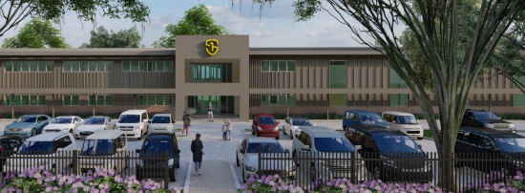 | Yes

Council’s Policy Implications (Other than DCP’s)

Lithgow Community Participation Plan

The development was publicly notified in accordance with the Lithgow Community Participation Plan 2020 (CPP) and the provisions of Environmental Planning and Assessment Regulations 2021 (EP&A Regulation). The notification period was for a minimum of 28 days from 21 March 2024 to 18 April 2024. During the notification period three (3) submissions were received with no objections subject to recommendations.

The submissions over the notification period raised the following issues:
- Lack of Infrastructure ie. walking and cycling facilities, bicycle parking, signage,
- Sustainable Design Elements, e.g. cross-flow ventilation, light colour roof, tree canopy across the carpark.
- Tree Canopy and Mental Wellbeing i.e. open space areas and vegetation,
- Fencing and Screening around boundaries,
- Stormwater and Easements,
- Traffic Impacts.

These submissions are outlined further under Section 4.3 in this report.

S7.12 Development Contributions
Council’s Local Infrastructure Contributions Plan (Section 7.12) 2024 applies to this development given it is for Educational Establishment (Private School) at an estimated cost of $10,817,262.00 (excluding GST).

Estimated cost of development | Levy applicable
$0 to $100,000 | 0%
$100,001 to $200,000 | 0.5%
$200,001 and over | 1%

As such, the following condition shall form part of the Development Consent:

Prior to the issue of a Construction Certificate the applicant shall pay to Council a Section 7.12 contribution of $108,172.62 in accordance with the Lithgow City Council Local Infrastructure Contributions Plan (Section 7.12) 2024. It is advised that the level of contribution in this plan may be adjusted at the time of actual payment, in accordance with the provisions of the Lithgow City Council Local Infrastructure Contributions Plan (Section 7.12) 2024.

- Section 4.15(1)(a)(iv) - Provisions of Regulations

Environmental Planning and Assessment Regulation 2021
The following relevant matters contained in the 2021 Regulation must be taken into consideration by a consent authority in determining a development application:
- Matters contained in Clause 61(1) including:
- If demolition of a building proposed - the provisions of AS 2601;
- If on land subject to subdivision order under Schedule 7, provisions of that order and any development plan;
- Dark Sky Planning Guideline if applicable;
- Low Rise Housing Diversity Design Guide for Development Applications (July 2020) if for manor house or multi dwelling housing (terraces).
- Matters in Cause 61 where the consent authority must be satisfied that the building complies (or will, when completed, comply) with such of the Category 1 fire safety provisions as are applicable to the building's proposed use.
- Matters in Clause 94 where the consent authority is to take into consideration whether it would be appropriate to require the existing building to be brought into total or partial conformity with the Building Code of Australia.
Council’s Building Officer has assessed the development and is satisfied that the fire safety provisions can be conditioned on the consent, should the application be approved.
  - Section 4.15(1)(b) - Likely Impacts of Development

The likely impacts of the development, including environmental impacts on both the natural and built environments, and social and economic impacts in the locality must be considered. In this regard, potential impacts related to the proposal have been considered in response to SEPPs, LEP and DCP controls outlined above and the key Issues section below.

The consideration of impacts on the natural and built environments includes the following:

Head of Consideration | Comment
Context and setting | The property is currently vacant with vacant land adjacent to the development; however, approved for a residential subdivision, and adjoins a service station and residential developments.  The school building is proposed to contain a setback of 33m from the front southern boundary, behind the proposed carparking area, 20m from the adjoining western boundary, 18m from the rear northern boundary and 41.8m from the adjoining eastern boundary.  As such, the development contains adequate setbacks to have no impact in terms of overshadowing or privacy to the adjoining properties.  The development proposes one main building consisting of two storeys and an orientation of a frontage to the street. The building is proposed to be located approximately within the middle of the property with landscaping and other infrastructure around the building.  The architectural design of the building includes the front facade of the building to contain timber batons, stepped out entry, different levelled roofing and natural tones/brickwork. This will help the visual streetscape by breaking the front wall elevation from being one straight orientation and a large rectangular building. The design and architectural details of the building would further help the development to look and feel like a school for the younger generation to attend.  The scale and massing of the development is considered to be much larger than developments on adjoining and adjacent land; however given the setbacks for the building and design of the development, it is expected that this will not be apparent from the streetscape.
Access, traffic and parking | Vehicle access is proposed to be via a separate entry and exit from Magpie Hollow Road to a parking area. This access is considered to be satisfactory for the development in terms of site safety.  The driveway has been designed to respond to the topography of the land with minimal earthworks proposed to be undertaken.  The access has been undertaken in accordance with Council’s Engineering Guidelines.  The carparking area is proposed to consist of 55 spaces, (including an accessible space, staff parking, and minivan parking) separate entry and exit from Magpie Hollow Road, drop off/pick up zone, pedestrian walkway, 2-way vehicle manoeuvring area and landscaping throughout.  The carparking area is proposed to be located in front of the building with security gates along the front and around the boundaries of the property.  It is expected that majority of the patrons utilising the facility will utilise the school mini van.  The amount of vehicle usage would be specific during school hours/days by patrons and employees. Given that the school is proposed to accommodate 114 students and approximately 20 staff, with Magpie Hollow Road containing minimal dwellings within the residential zone prior to larger allotments in the rural zone, the vehicle usage is considered adequate for the development and road capacity.  Magpie Hollow Road is further a public road, designed and is suitable for additional developments.
Public Domain | The development is proposed to be located on an existing vacant allotment, with the development surrounded by different types of commercial/residential uses.  The property is located approximately 105m from the corner of the Great Western Highway and Magpie Hollow Road, approximately 10km to the Lithgow Town Centre, and approximately 5km to a popular tourist attraction known as Lake Lyell.  As such the development is within proximity to public open space areas and is proposed to contain a pedestrian linkage to the adjoining service station.  The development will have minimal impact to the public domain given the location being surrounding by built and future developments.
Utilities | Water, sewer, electricity and telecommunication utilities will be provided to the development to the requirements of the respective public utility authority.
Water/air/soil impacts | Water impacts have been assessed by WaterNSW and is found to be adequate for the development subject to conditions on the consent.  The development, once operational will have no impact on air quality. Conditions relating to dust will be conditioned on the consent during construction work.  The applicant has demonstrated through design plans, how the proposed development complies with the earthwork requirements including the need for potential retaining walls.  The development proposes a maximum of approximately 1.5m of fill (majority to be located towards the north/rear of the development project area) and approximately 1m of cut around the southern/front section of the development (carparking and part of the built site).  1.5m High sandstone block retaining walls are proposed to be constructed around the south eastern corner and south western corner of the property for containment of soils.  The proposed development will have minimal impacts on drainage patterns and soil stability in the locality through construction in accordance with the stormwater management plan.  Conditions of consent have been imposed to ensure dust, noise and erosion impacts are minimised during works and in perpetuity as a result of the earthworks.  In addition, earthworks are proposed to be undertaken as a result of contamination from asbestos and previous fill to a dam. Refer to sections in this report relating to contamination for more details.  Conditions of consent will also be imposed to control erosion and sedimentation impacts on the site
Noise and vibration | Noise is expected during the construction of the development with standard conditions of consent restricting to hours.  Noise during operational hours is not expected to be high volumes due to the nature and purpose of the development. The main hours of operation are between 8am to 4pm Monday to Friday, with the adjoining service station being operation 24hrs, 7 days a week.  The school bell times is proposed to operate 6 times a day, that consists of a single chime. Noise from vehicles would be prior to the school commencement and at the end of the school day. Given that there is proposed to be a maximum 114 students, and the scale, time operations being during daylight hours, it is expected that noise will have minimal impacts to the surrounding landuses.  The development is further located within proximity to the Great Western Highway, while adjoining a busy service station. The development contains appropriate setbacks from boundaries and landscaping around the site that would decrease potential noise impacts from the highway and service station activities.  Noise will be mitigated via the Operations Management Plan, that will be conditioned on the consent.
Natural Environment | Based on the information submitted, an assessment of the proposal and a site inspection, the development is considered to involve earthworks to level the site and to remediate past contamination. Subject to conditions on the consent and an assessment from external government authorities, such as WaterNSW, the development is unlikely to result in adverse impacts on the natural environment.
Social and Economic Impact | In relation to social and economic outcomes, it is to be noted that The Trustee for Katoomba Education Trust (developers) currently operate a school (known as OneSchool Global) in Mount Victoria (Blue Mountains Local Government area). This school is proposed to be closed should the current application be approved and constructed due to an increase in participants and the need for a larger facility. The school at Mount Victoria was previously utilised as a community hall.  Therefore, the development is expected to provide additional employment (during construction and once operational), housing and an increase in population to the Lithgow Local Government Area. As such the development would create a positive economic and social impact.
Natural hazards | The site is affected by bushfire, with the Rural Fire Service satisfied with the development subject to conditions on the consent.
Safety, security and crime prevention | The development proposes sufficient security measures around the site; such as fencing, landscaping and alarms. An Operational Management Plan will also be conditioned on the consent to address safety and security.

  - Section 4.15(1)(c) - Suitability of the site

The site is considered suitable for an educational facility for the following reasons:

- The development is consistent with the objectives and permissible under the applicable land use zone under the Lithgow LEP 2014.
- The constraints of the site have been considered in the development, which includes bushfire, contamination, water quality, easements, traffic, access and parking and potential impacts to adjoining property owners.

The site is not subject to any other known risk or hazard that would render it unsuitable for the proposed development.

  - Section 4.15(1)(d) - Public Submissions

These submissions are considered in Section 5 of this report.

  - Section 4.15(1)(e) - Public interest

The development is considered to be in the public interest and is likely to result in significant housing accommodation for a facility that is in need in the locality, employment and economic benefits.

- REFERRALS AND SUBMISSIONS

  - Agency Referrals and Concurrence

The development application has been referred to various agencies for comment/concurrence/referral as required by the EP&A Act and outlined below in Table 4.

There are no outstanding issues arising from these concurrence and referral requirements subject to the imposition of the recommended conditions of consent being imposed.

Table 2: Concurrence and Referrals to agencies
Agency | Concurrence/  referral trigger | Comments  (Issue, resolution, conditions) | Resolved
Concurrence Requirements (s4.13 of EP&A Act)
Water NSW | Section 6.5 of the Biodiversity and Conservation SEPP (Chapter 6 - Sydney Drinking  Water Catchment) | Water NSW considers that the proposed development can achieve a neutral or beneficial effect (NorBE) on water quality. Water NSW further provided appropriate conditions that are to be included in any development consent (17 July 2024 and amended 9 October 2025). | Yes
Rail authority for the rail corridor | Section 2.98(3) - State Environmental Planning Policy (Transport and Infrastructure) 2021 | N/A | N/A
Referral/Consultation Agencies
RFS | S4.14 – EP&A Act  Development on bushfire-prone land | Refer to below comment under Integrated Development section. | Yes
Electricity supply authority | Section 2.48 – State Environmental Planning Policy (Transport and Infrastructure) 2021 Development near electrical infrastructure | Endeavour Energy has advised that the proposal is satisfactory subject to conditions. Refer to response received 11 October 2024. | Yes
Rail authority | Section 2.97 – State Environmental Planning Policy (Transport and Infrastructure) 2021  Development land that is in or adjacent to a rail corridor. | N/A | N/A
Transport for NSW | Section 2.121 – State Environmental Planning Policy (Transport and Infrastructure) 2021  Development that is deemed to be traffic generating development in Schedule 3. | TfNSW’s primary interests are in the road network, traffic, and broader transport issues. In particular, the efficiency and safety of the classified road network, the security of property assets and the integration of land use and transport.  Review of the additional information provided has indicated that the increased traffic associated with the proposed development will have a negligible impact to the performance of the existing intersection with the classified (State) road. Additionally, swept paths provided by the applicant for the indicated design vehicle (mini-van) has illustrated that right-turns onto HW5 can be safely executed within the current intersection arrangement.  Transport for NSW therefore has no objection to the application subject to recommendations for Council to consider. | Yes
Department of Education | Chapter 3 Educational establishments and child care facilities - State Environmental Planning Policy (Transport and Infrastructure) 2021 | N/A- Council undertook a concurrence referral to the Department of Education; however, following a review of the application the Department of Education deemed the referral not required given that the development is a non-government school with no childcare services. | Yes
Integrated Development (S 4.46 of the EP&A Act)
RFS | S100B - Rural Fires Act 1997  bush fire safety of subdivision of land that could lawfully be used for residential or rural residential purposes or development of land for special fire protection purposes. | The New South Wales Rural Fire Service (NSW RFS) has considered the information submitted. General Terms of Approval, under Division 4.8 of the Environmental Planning and Assessment Act 1979, and a Bush Fire Safety Authority, under section 100B of the Rural Fires Act 1997 (2 May 2024). | Yes
Subsidence Advisory | Clause 22 – Coal Mine Compensation Act 2017 requires approvals for development within mine subsidence districts. | N/A | N/A
Natural Resources Access Regulator | S89-91 – Water Management Act 2000 water use approval, water management work approval or activity approval under Part 3 of Chapter 3. | N/A | N/A

  - Council Officer Referrals

The development application has been referred to various Council officers for technical review as outlined Table 5.

Table 3: Consideration of Council Referrals
Officer | Comments | Resolved
Engineering | Council’s Engineering Officer reviewed the submitted Traffic and Parking Impact Assessment and considered that there were no objections subject to conditions. Response received October 2025. | Yes  (conditions)
Building | Council’s Building Officer reviewed the submitted documentation and considered that there were no objections subject to standard conditions. Response received 21 May 2024. | Yes  (conditions)
Environmental | Council’s Building Officer reviewed the submitted stormwater concept plan and considered that there were no objections subject to conditions. Response received 5 April 2024. | Yes  (conditions)
Water and Wastewater | Council’s Water and Wastewater Officer reviewed the submitted stormwater concept plan and considered that there were no objections subject to conditions. Response received 17 April 2024. | Yes  (conditions)
Trade Waste Officer | Council’s Trade Waste Officer reviewed the submitted plan and considered that there were no objections subject to conditions. Response received 27 March 2024. | Yes  (conditions)

  - Community Consultation

The development was publicly notified in accordance with the Lithgow Community Participation Plan 2020 (CPP) and the provisions of Environmental Planning and Assessment Regulations 2021 (EP&A Regulation). The notification period was for a minimum of 28 days from 21 March 2024 to 18 April 2024.

- Notification letters sent to adjoining and adjacent properties.
- Notification on the Council’s website.

During the notification period three (3) submissions were received with no objections subject to recommendations.

The applicant received all submissions to address the concerns raised.

The issues raised in these submissions are considered in the Table below:

Table 6: Community Submissions

Community Concern | Applicants Comments | Council Comments
Active School Travel  Lack of Infrastructure ie. walking and cycling facilities, bicycle parking, signage | A summary of the community concerns were referred to the applicant by Council to make comment.  No specific comments were made by the applicant, however; amended plans were received on 6 November 2024 after the notification period was undertaken.  The amended plans appear to address the submissions. | The amended plans show a 1.2m wide concrete footpath to be constructed along the front of the school and to connect with the service station. This would facilitate and encourage walking and cycling to the school.  24 bicycle parking spaces are proposed to be provided for the development. These spaces are to be located towards the western side of the building This is considered satisfactory.
Heat Mitigation and Water Efficiency  Sustainable Design Elements, e.g. cross-flow ventilation, light colour roof, tree canopy across the carpark. |  | An external colour schedule was submitted to show the roof sheeting to be a ‘Colourbond Gully’ colour.  An amended landscaping plan was also submitted that shows tree canopy to be located across the site.  The internal floor plan was also amended to provide cross-flow ventilation.
Tree Canopy and Mental Wellbeing i.e. open space areas and vegetation |  | The amended landscaping plans show open space areas around the playground area and numerous tree cover.
Fencing and Screening around boundaries |  | The amended plans show the development to contain a 1.8m high palisade fence around the site with security gates proposed for the driveway.  The plans are considered to contain adequate fencing and landscaping around the boundaries to help to visually screen the development from adjoining properties.
Stormwater and Easements |  | Currently, there are no formal stormwater management measures at the site with runoff draining to the north towards Kirkley Street via uncontrolled overland flows. As part of the development, a new pit and pipe network is to be constructed to capture all runoff from the roof and hardstand areas, discharging into the existing network in Kirkley Street.  In order to achieve this, the new stormwater line and easement is proposed through Lot 21 DP 816671, 7 Kirkley Street South Bowenfels.  A stormwater management plan was submitted with the application and demonstrates irrigation systems, rainwater tanks and a bio-retention system to be utilised for the development.  The stormwater management has been assessed against the WaterNSW water quality guidelines and Norbe Assessment.  The development was referred to WaterNSW who has given concurrence subject to conditions on the consent.  The development was also assessed by Council’s Engineers who considers the development to have adequate drainage.
Additional Traffic Impacts and Safety |  | It is expected that majority of the patrons utilising the facility will utilise the school mini van.  The amount of vehicle usage would be specific during school hours/days by patrons and employees. Given that the school is proposed to accommodate 114 students and approximately 20 staff, with Magpie Hollow Road containing minimal dwellings within the residential zone prior to larger allotments in the rural zone, the vehicle usage is considered adequate for the development and road capacity.  Magpie Hollow Road is further a public road, designed and is suitable for additional developments.  The development has further been assessed by Transport for NSW and Council’s Engineers and considered adequate for the development.

- KEY ISSUES
The following key issues are relevant to the assessment of this application having considered the relevant planning controls and the proposal in detail:

  - Safety
The development proposes fencing and security around the boundaries of the site. The facility will further be managed and maintained by staff. An Operational Management Plan will be conditioned on the consent to manage potential safety concerns. As such, it is considered the development satisfies potential safety concerns.

  - Noise
Noise is expected during the construction of the development with standard conditions of consent restricting to hours.

Noise during operational hours is not expected to be high volumes due to the nature and purpose of the development.

Noise will be mitigated via the Operations Management Plan, that will be conditioned on the consent.

  - Contamination
As assessed throughout this report, the property has been impacted by contamination involving asbestos and fill of a former dam on the site. Therefore, remediation conditions are included on the consent should the application be approved.

  - Scale & Character
The design and scale of the development is considered to be suitable for the property. The total site area consist of 1.17ha with the total area of the built construction area to consist of approximately 2,560.07m².

The scale and massing of the development is considered to be much larger than developments on adjoining and adjacent land; however given the setbacks for the building and design of the development, it is expected that this will not be apparent from the streetscape.

The development involves adequate parking areas, pedestrian access, open space and landscaped areas.

As such it is considered that the size and scale of the development will be compatible with the surrounding landuses.

  - Traffic Impacts
Vehicle access is proposed to be via a separate entry and exit from Magpie Hollow Road to a parking area. This access is considered to be satisfactory for the development in terms of site safety.

The driveway has been designed to respond to the topography of the land with minimal earthworks proposed to be undertaken.

The access has been undertaken in accordance with Council’s Engineering Guidelines.

The carparking area is proposed to consist of 55 spaces, (including an accessible space, staff parking, and minivan parking) separate entry and exit from Magpie Hollow Road, drop off/pick up zone, pedestrian walkway, 2-way vehicle manoeuvring area and landscaping throughout.

The carparking area is proposed to be located in front of the building with security gates along the front and around the boundaries of the property.

It is expected that majority of the patrons utilising the facility will utilise the school mini van.

The amount of vehicle usage would be specific during school hours/days by patrons and employees. Given that the school is proposed to accommodate 114 students and approximately 20 staff, with Magpie Hollow Road containing minimal dwellings within the residential zone prior to larger allotments in the rural zone, the vehicle usage is considered adequate for the development and road capacity.

Magpie Hollow Road is further a public road, designed and is suitable for additional developments.

- CONCLUSION

This development application has been considered in accordance with the requirements of the EP&A Act and the Regulations as outlined in this report. Following a thorough assessment of the relevant planning controls, issues raised in submissions and the key issues identified in this report, it is considered that the application can be supported.

It is considered that the key issues outlined in the report have been resolved satisfactorily through amendments to the proposal and/or in the recommended draft conditions in Attachment A.

- RECOMMENDATION

That the Development Application DA016/24 for Educational Establishment (Private School) at Lot 1 DP 527491, Magpie Hollow Road, South Bowenfels NSW 2790 be APPROVED pursuant to Section 4.16(1)(a) of the Environmental Planning and Assessment Act 1979 subject to the draft conditions to this report at Attachment A.

The following attachments are provided:

- Attachment A: Draft Conditions of consent
- Attachment B: Architectural Plans
- Attachment C: External Renders
- Attachment D: General Arrangement Plan
- Attachment E: Carpark Certification
- Attachment F: Road Signage Plan
- Attachment G: Traffic and Impact Assessment
- Attachment H: Vehicle Swept Paths
- Attachment I: Landscape Plans
- Attachment J: Earthworks Plan
- Attachment K: Retaining Wall Construction Details
- Attachment L: Bush Fire Assessment Report
- Attachment M: Construction Management Plan
- Attachment N: External Colour Schedule
- Attachment O: Geotechnical Investigation Report
- Attachment P: Noise Assessment
- Attachment Q: Operations Manual
- Attachment R: Preliminary Site Investigation with Targeted Sampling
- Attachment S: Security Fencing Brochure
- Attachment T: NABERS Embodied Emissions Report
- Attachment U: Flood Impact Statement
- Attachment V: Water Cycle Management Study
- Attachment W: Road Safety Audit

